Extended Circulation Test Report
Utah FORGE 16A(78)-32 and 16B(78)-32

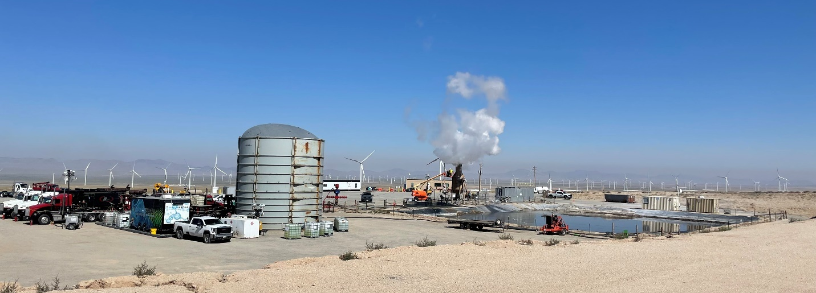

Prepared by:

Kevin England
Leroy Swearingen
John McLennan

October 2024

Contents
Executive Summary 3
Introduction 4
Before Operations: 4
Workover 4
Circulation Testing 5
Circulation 6
Sampling and Additive Metering/Testing Procedure 26
Pre-Test Assessments 26
Assessments During Pumping 28
Injection Records 28
Appendix A: Nine-hour Circulation Test (April 27, 2024) 33
Appendix B: On-Location Water Analyses 36

Executive Summary

Parameter | Well 16A(78)-32 | Well 16B(78)-32
Northing of Wellhead | 13987645.20 ft | 13987765.96 ft (UTM 4263471.065)
Easting of Wellhead | 1097896.92 ft | 1097907.09 ft (UTM 334642.081)
KB Elevation | 5,445.6 | 5,447.65 ft (confirm)
GL Elevation | 5,415.1 ft | 5,415.65 ft
Kick-off Depth | 5,938 ft | 5,600 ft
Azimuth of Tangent | 105 | 105
Build Rate | 5°/100 ft | 5.5°/100 ft
Total Measured Depth | 10,938.3 ft | 10,700.97 ft
True Vertical Depth at Toe | 8,540.5 ft | 8,262.48 ft

An extended injection test – injecting into well 16A(78)-32 and producing from 16B(78)-32 confirmed a high efficiency (ratio of mass flow rate out to mass flow rate in), demonstrated temperatures approaching 380°F (Figure i), proved the effectiveness of the scaling inhibition program that was adopted and showed that the injection pressures were high but starting to decline slightly.

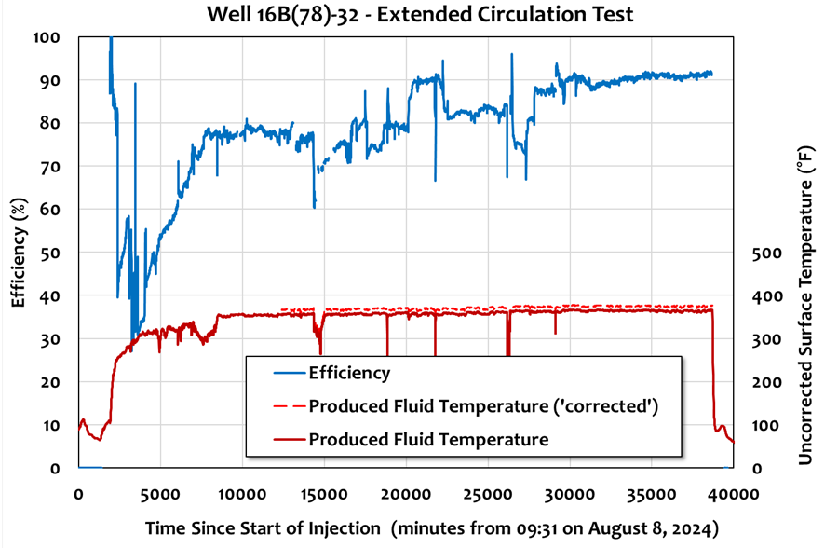
Figure i. The ratio of mass flow rates was used to calculate the efficiency – approximately 90%.

Introduction
A nine-hour circulation between wells 16A(78)-32 and 16B(78)-32 was completed on April 27, 2024, at a final rate of ~13 bpm. That test is summarized in Appendix A. The extended circulation commenced on August 8 and circulated at 10 bpm between wells 16A(78)-32 and 16B(78)-32. Certain well operations preceding the circulation test are described, along with the testing itself. The water circulated was sourced from well 58B-32.

Before Operations:
Before the beginning of operations, the 16A/B pad sump was partially cleaned out. The atmospheric separator was modified with a larger diameter inlet and two 3-inch SCH 80 outlet lines. Ports for sampling were fabricated for routine sampling and connection of a mini-separator. Rental equipment (telehandler, manlift, light plants, etc.) was offloaded. A 3,600 bbl Minion tank was erected, water transfer pumping equipment was spotted, and hoses were laid out. Instrumentation was installed for workover operations and circulation testing. All daily reports for this activity are available on the Geothermal Data Repository.

Workover
It was desirable to run a Kinley caliper to inspect the character and integrity of the 7” production casing near the casing shoe of well 16B(78)-32. Wireline deployment failed beyond 7,740 ft MD. Before that, a Delsco Northwest (UDES) workover rig ran a casing scraper to just above the PetroQuip landing profile sub and subsequently attempted to remove an obstruction located about 20 ft below the 7” casing shoe. Table 1 summarizes workover activities.

Table 1. Pre-Circulation Activities
Well 16A(78)-32 | Well 16B(78)-32
 | July 30-31: Rig up workover rig on well 16B(78)-32 for cleanout, along with flow lines, hoses, transfer pumps, and sensors for the flow testing.
 | August 1-August 4: Clean out frac plug debris, bridge plug debris, and proppant in the casing and for a short distance into the open hole (shoe at 10,208 ft MD). Insufficient rig capacity to remove blockage below the shoe. Diutan polymer was used as required for viscous slugs, with no issues.
August 5: MIRU Liberty Oilfield Services and wait on 16B(78)-32 operations | August 5: Rigging down UDES workover rig.
 | August 6-7: Running Kinley caliper on bogey - reached 7,740 ft MD. The results (logging to the surface) are of no immediate value, other than showing that the casing was in good condition. Later wireline runs of other tools would get deeper.

Circulation Testing
The circulation system layout is shown in Figures 1 and 2. Ambient temperature water was transferred from the 125,000 bbl pit to the Minion tank and then to the Shalestone water treatment trailer where a corrosion inhibitor and a dual-function scale inhibitor (calcite and sulfate) were metered in. This is transferred to the Liberty high pressure pump trucks (two pumping and one standby). On the suction side is a Liberty Liquid Additive System (LAS) where tracers were added by RESMAN, QuantumPro, and Peter Rose from EGI. After injection down well 16A(78)-32 and movement through the fracture network and to the surface through well 16B(78)-32, fluid is flowed through instrumented (pressure, temperature, flow rate, etc.) lines, an atmospheric geothermal separator and into the 16A/B-32 sump for immediate cooling. The 75,000 bbl pit was not used in the circulation testing. The returned water to the sump was pumped back to the 125,000 bbl pit. To account for steam loss, evaporation, and small losses in the formation, the 125,000 bbl pit was recharged with water from well 58B-32.

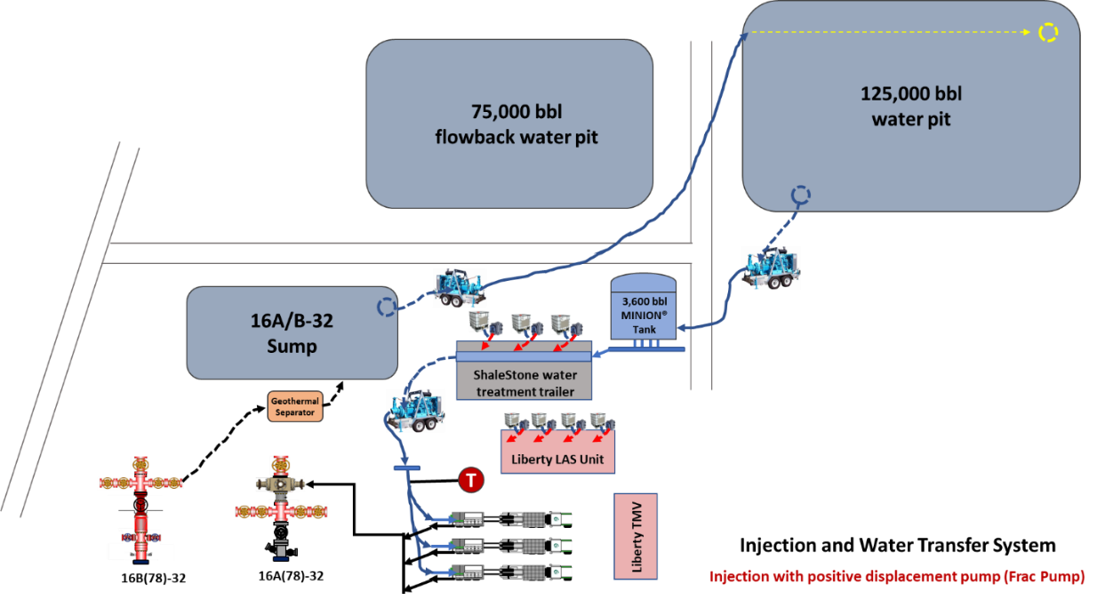
Figure 1. A schematic view of the circulation operations.
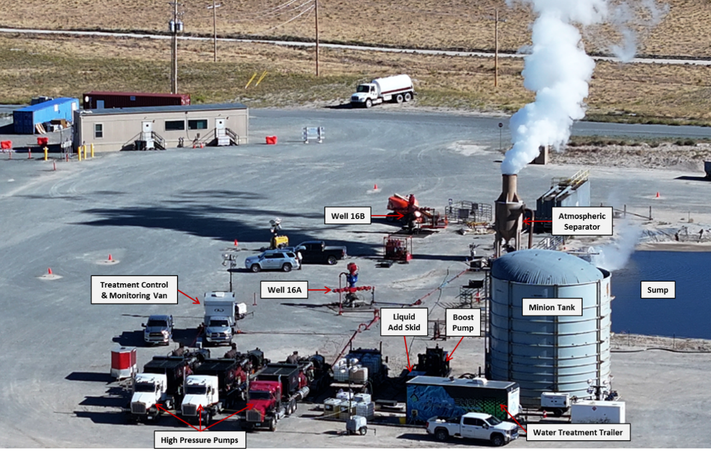

Figure 2. Aerial view of the circulation setup with main components identified. Looking about NNW.

The instrumentation layout is shown in Figure 3. Of note are the sand separator in case proppant or other debris was produced back, the atmospheric separator to flash returning fluid to steam, redundant flow, and pressure equipment.

Circulation
The nominal pumping schedule (adhered to fairly closely despite slight modifications driven by operations) is shown in Table 2. All data are available on the Geothermal Data Repository (GDR).

Table 2. Nominal Pumping Schedule

Step | Rate (bpm) | Volume (bbl) | Cumulative Volume (bbl) | Incremental Time (day) | Cumulative Time (day) | Well 16B(78)-32 Status
1 | 0 | 0 | 0 | 0 | 0 | Shut-In
2 | 2.5 | 3.600 | 3,600 | 1.0 | 1.0 | Shut-In
3 | 0 | 0 | 3,600 | 0.33 | 1.33 | Shut-In
4 | 2.5 | 1,200 | 4,800 | 0.33 | 1.67 | Open
5 | 5 | 3,600 | 8,400 | 0.5 | 2.17 | Open
6 | 7.5 | 7,200 | 15,600 | 0.67 | 2.84 | Open
7 | 10 | 391,104 | 406,704 | 27.16 | 30.00 | Open
8 | 0 | 0 | 406,704 | TBD | TBD | Shut-In
Table 3 summarizes the chronology of the first 6 steps shown in Table 2, low rate injection with shut-in and stepped injection stages on the way to 10 bpm.

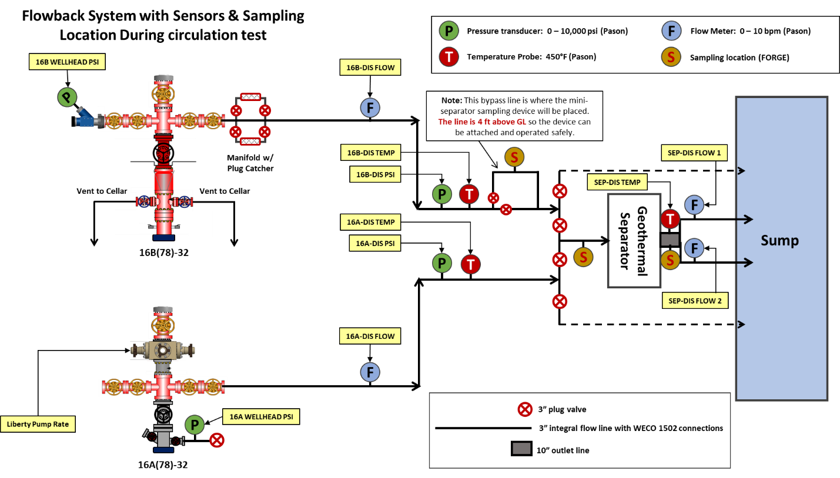

Figure 3. Piping diagram and instrumentation.

Table 3. Early Circulation Activities

Well 16A(78)-32 | Well 16B(78)-32
August 8-9: Start Circulation at 2.5 bpm. Pumped ~3,600 bbl | August 8-9: Well Shut-In
August 9: Shut-in well for 8 hours | August 9 (17:00): Open well to separator
August 9 (17:00): Start pumping at 2.5 bpm
August 10 (01:00) Start pumping at 5 bpm
August 10 (13:00) Start pumping at 7.5 bpm

The chronology of activities through August 16, 2024, is shown in Table 4. Pumping at 10 bpm continued through this period. The acquisition of data from the fiber optics on the outside of the 7” casing on well 16B(78)-32 ceased because of a connection failure at the surface junction box; this occurred on August 11, 2024. It appears that a fitting had not been energized. The fibers were respliced (August 12, 2024). August 16, 2024, the University of Texas/Shell flatpack failed below about 4560 ft. Over time since then, functionality has been lost below about 4200 ft (Dana Jurik, personal communication).
Table 4. Mid-term Circulation Activities

Well 16A(78)-32 | Well 16B(78)-32
August 11 (06:00): Start pumping at 10 bpm | August 11: Fibers severed at junction box because of failure of fitting
Tracers run by RESMAN, QuantumPro and Peter Rose (EGI) – and run periodically thereafter and sampled regularly | August 12: Neubrex resplices fibers
August 11 onwards: Continue pumping at 10 bpm | August 16: Failure of flatpack fiber optics cable below 4560 ft
August 16 and 23: Mini-separator sampling

Late-term circulation activities are shown in Table 5. Of note is the depth reached by the SNL/Stanford tool in well 16B(78)-32, much deeper than the attempted Kinley caliper run and somewhat deeper than the subsequent PLT/PTS survey. The tool schematic is shown in Figure 4. The final profile also included weight bars and PetroMac rollers to facilitate deep entry into the wellbore.

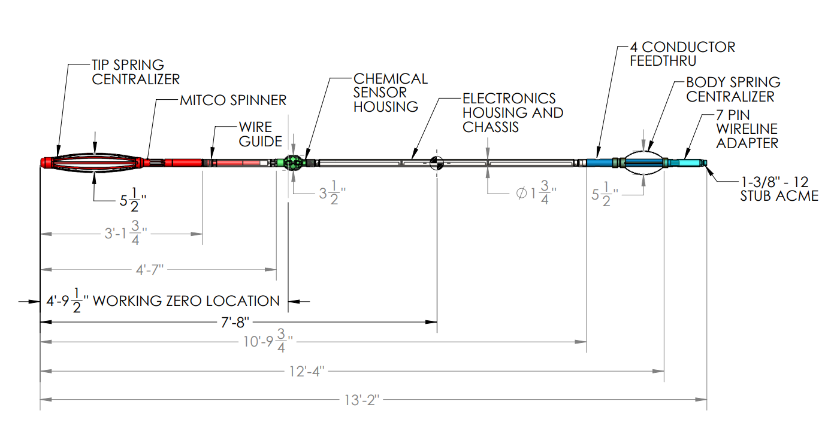
Figure 4. Chemical Sensor Wireline Tool Assembly Drawing

Figures 5 and 6 are screen shots of typical EV ClearVision downhole tool images and data. The obstruction at 10,100 ft ± in Well 16A(78)-32 appeared to be frac sand. The origin of this sand is speculative – it could have come from a stage pumped on well 16B(78)-32 or an unusual circulation system may be occurring at the toe of well 16A(78)-32. EV ClearVision images and data analysis will be posted to the GDR.

Table 5. Late-term Circulation Activities

Well 16A(78)-32 | Well 16B(78)-32
August 17: Run SLB PLT – reached 10,095 ft MD | August 19: RIH and log with SNL/Stanford chlorides detection tool (reached 9,480 ft MD)
August 18: Run EV ClearVision logging tool – tag obstruction in different runs at 10,099 to 10,130 ft MD | August 28: Run Di Drill PLT/PTS on memory (reached 9,280 ft MD)
Sept 4: California State University at Long Beach (CSULB) runs injection-flowback test | August 29: Sage Rider West runs Silixa intervention fiber for Rice University (reached 6,809 ft and binding)
Sept 4: Liberty calibrates downstream flow meters against their flow measurements. | Di Drill attempts to fish Sage Rider/Rice intervention cable, binds, and eventually recovers fishing cable (cut at rope socket) but loses BHA, including weight bars

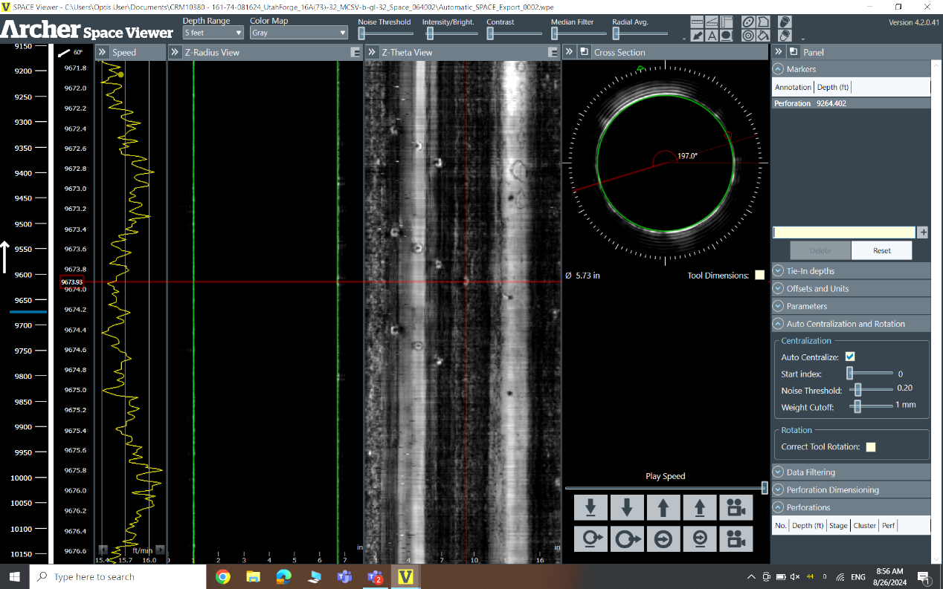

Figure 5. View of perforations at 9672 to 9675 ft MD in Well 16A(78)-32. Illustrative depth only, acquired acoustically.

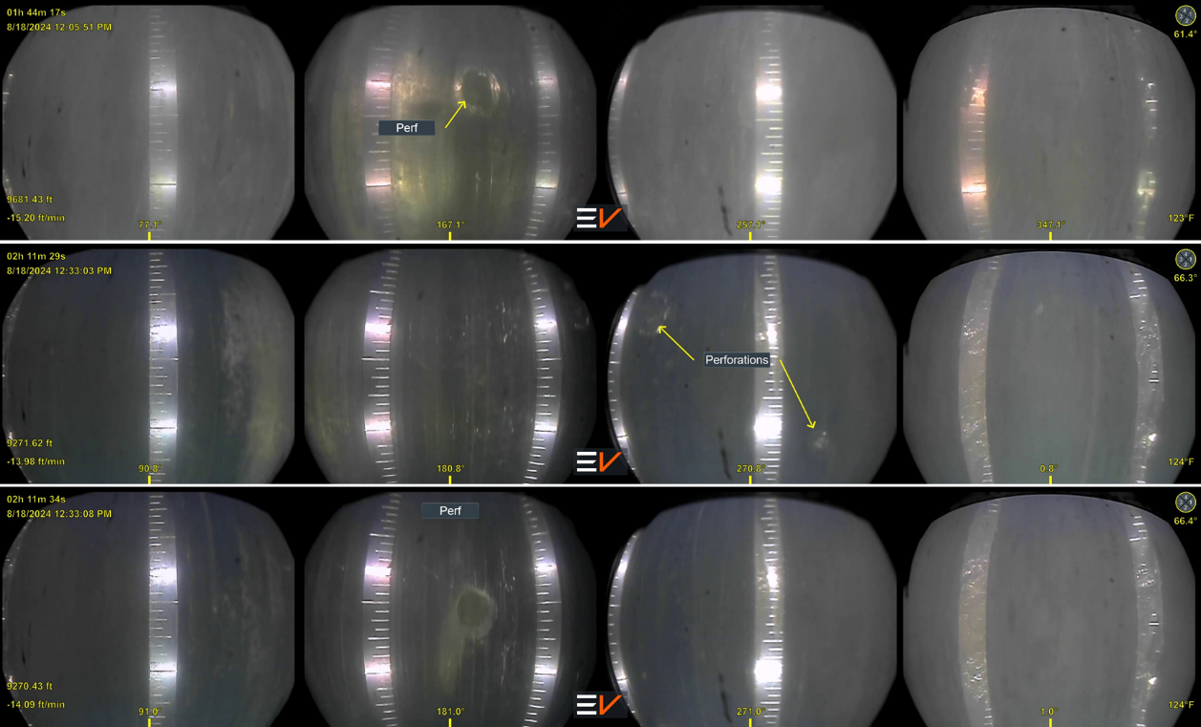

Figure 6. View of perforations at several depths in Well 16A(78)-32. Illustrative depth only, acquired with camera.

The interpreted results of the PLT/PTS survey run in well 16A(78)-32 is shown in Table 6 and Figures 7 through 14. The survey was carried out so that discrete clusters could be surveyed (see Table 7).

Table 6. Stage-Wise Partitioning of Flow for PLT/PTS in well 16A(78)-32
[Injection is negative]

Stage | Perforations |  | Water  (bpd) | Water  (%)
10 | 9,270 | 9,276 | -3728.4 | 25.8
9 | 9,320 | 9,493 | -2539.4 | 17.6
8 | 9,545 | 9,723 | -3768.7 | 26.1
7 | 9,798 | 9,901 | 0.0 | 0.0
6 | 9,959 | 9,976 | 0.0 | 0.0
5 | 10,020 | 10,026 | 604.2 | 4.2
4 | Below 10,026 |  | -3825.7 | 26.4
3R |  |  | -3825.7 | 26.4
Totals |  |  | -14,466.4 | 100.0

Table 7. Cluster-Wise Partitioning of Flow for PLT/PTS in well 16A(78)-32
[Injection is negative]

Stage | Perforations |  | Water | Water
Stage |  |  | (bpd) | (%)
10 | 9270 | 9276 | -3728.4 | 25.8%
9 | 9320 | 9323 | -201.5 | 1.4%
9 | 9345 | 9348 | -362.8 | 2.5%
9 | 9370 | 9373 | -644.9 | 4.5%
9 | 9395 | 9398 | -725.5 | 5.0%
9 | 9420 | 9423 | -151.2 | 1.0%
9 | 9445 | 9448 | -90.7 | 0.6%
9 | 9470 | 9473 | -100.8 | 0.7%
9 | 9490 | 9493 | -262.0 | 1.8%
8 | 9545 | 9548 | -100.8 | 0.7%
8 | 9570 | 9573 | -100.8 | 0.7%
8 | 9595 | 9598 | -80.6 | 0.6%
8 | 9620 | 9623 | -201.5 | 1.4%
8 | 9645 | 9648 | -1410.7 | 9.8%
8 | 9670 | 9673 | -1007.7 | 7.0%
8 | 9695 | 9698 | -443.4 | 3.1%
8 | 9720 | 9723 | -423.2 | 2.9%
7 | 9798 | 9801 | 0.0 | 0.0%
7 | 9850 | 9853 | 0.0 | 0.0%
7 | 9898 | 9901 | 0.0 | 0.0%
6 | 9959 | 9962 | 0.0 | 0.0%
6 | 9970 | 9976 | 0.0 | 0.0%
5 | 10020 | 10026 | -604.2 | 4.2%
4-3R | below 10026 |  | -3825.7 | 26.4
Totals |  |  | -14466.4 | 100.0%
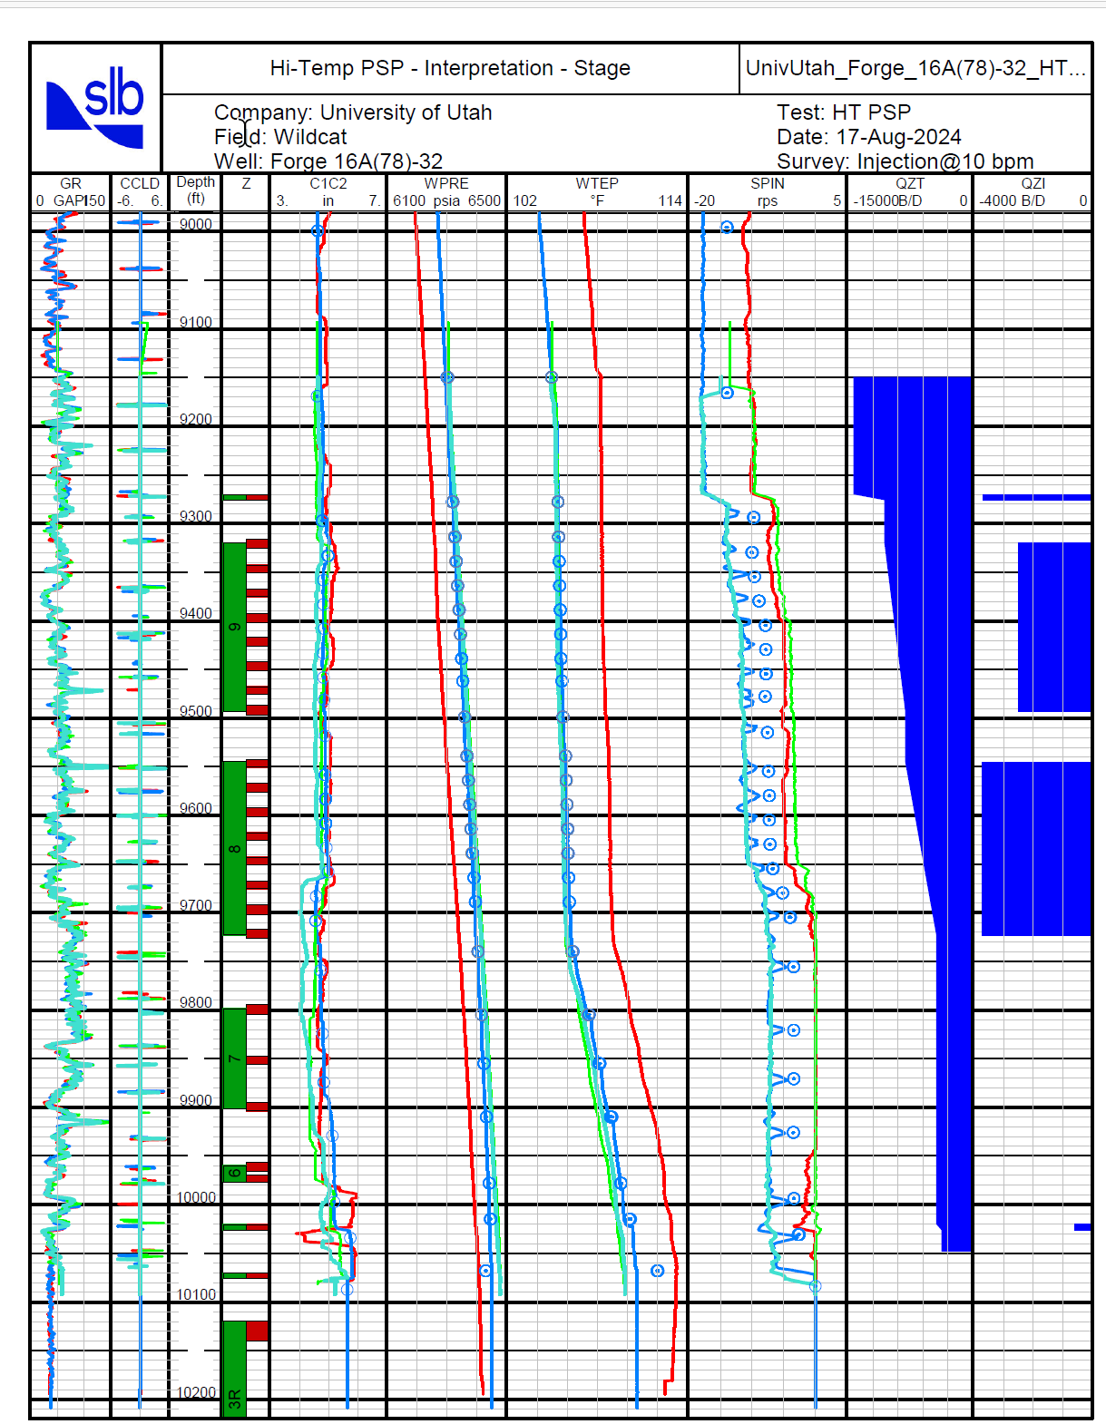

Figure 7. Injection profile in well 16A(78)-32.
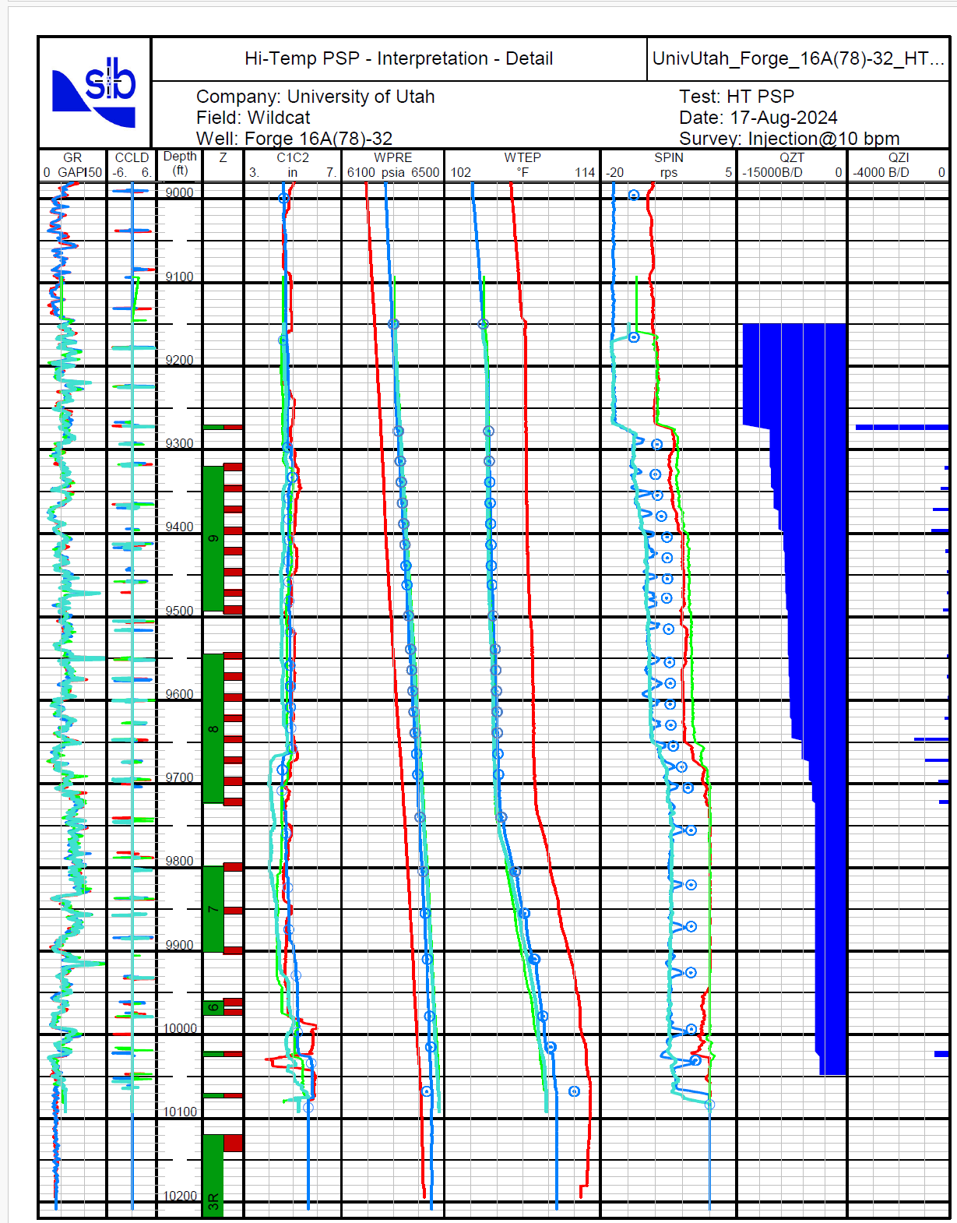

Figure 8. Injection profile in well 16A(78)-32.
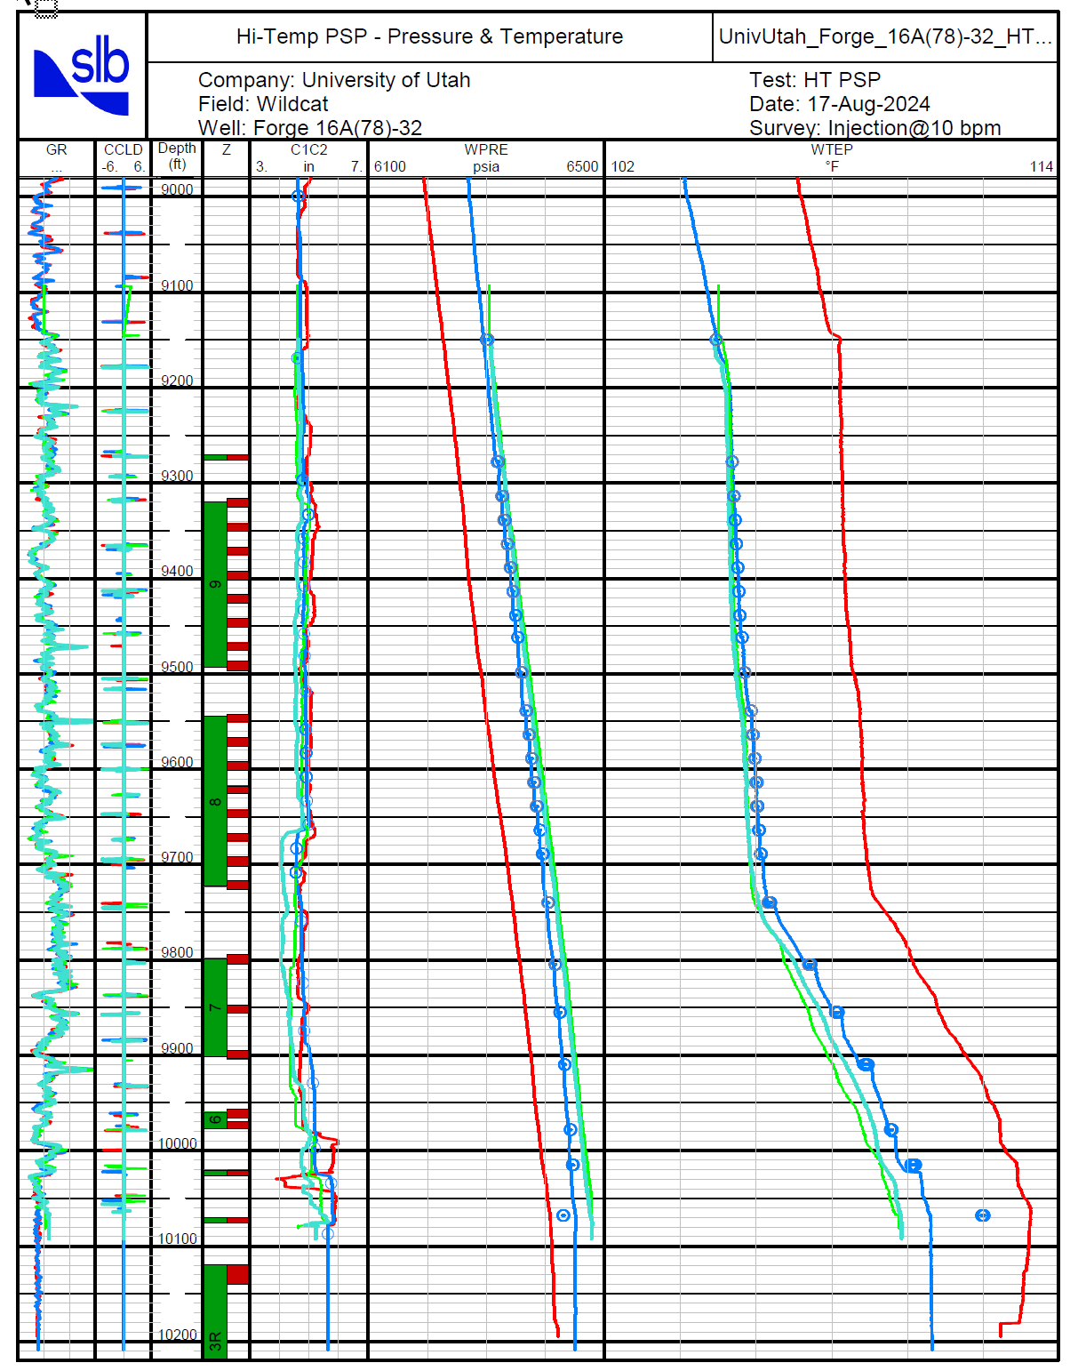

Figure 9. Injection profile in well 16A(78)-32.

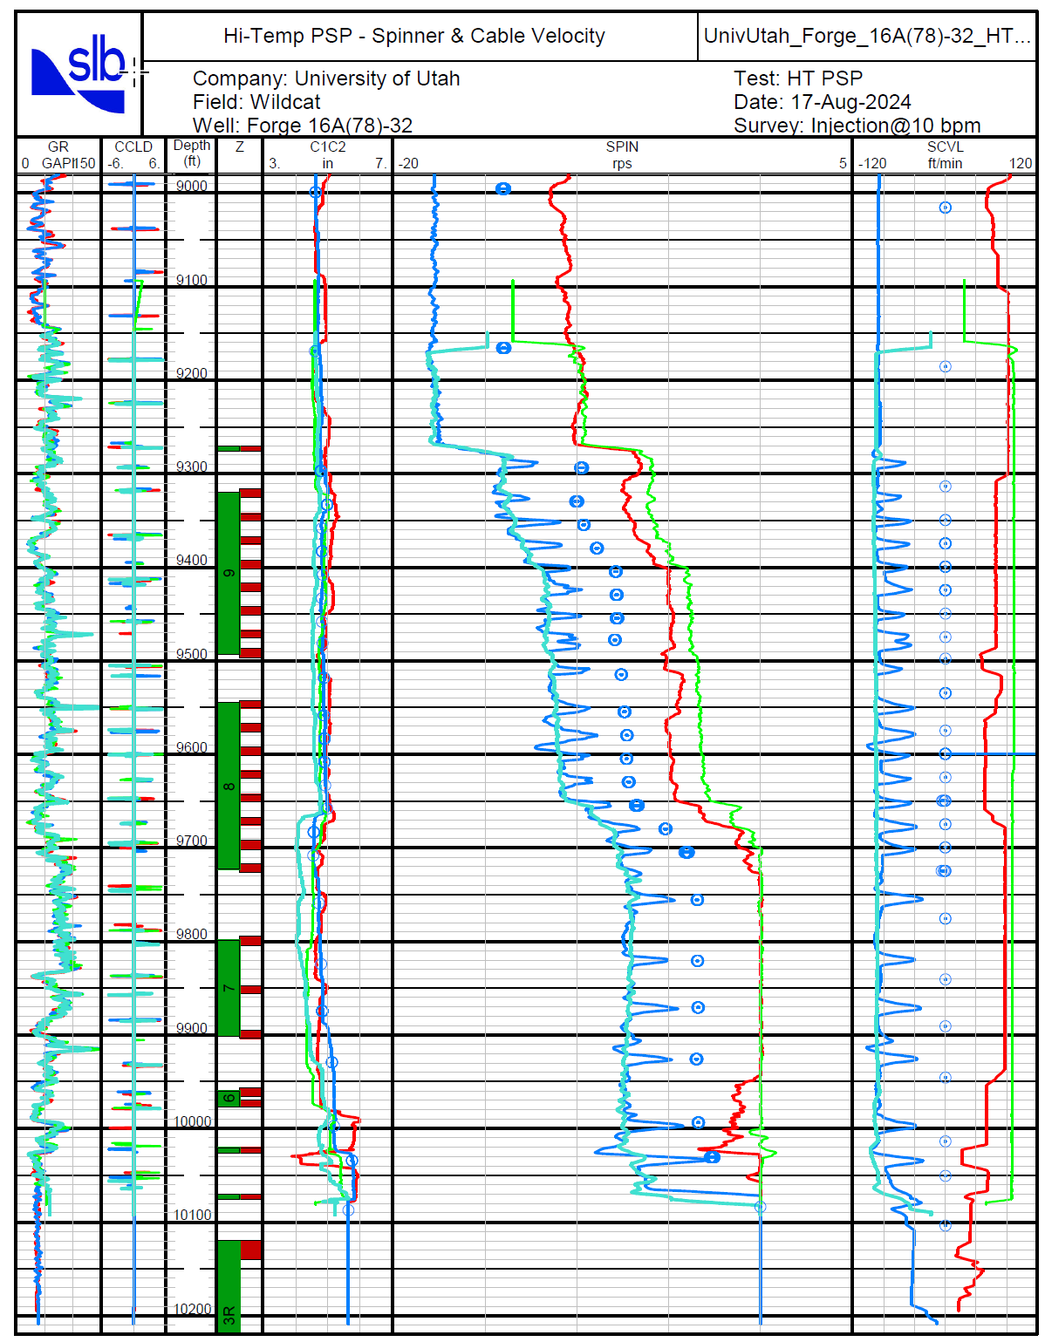

Figure 10. Injection profile in well 16A(78)-32.
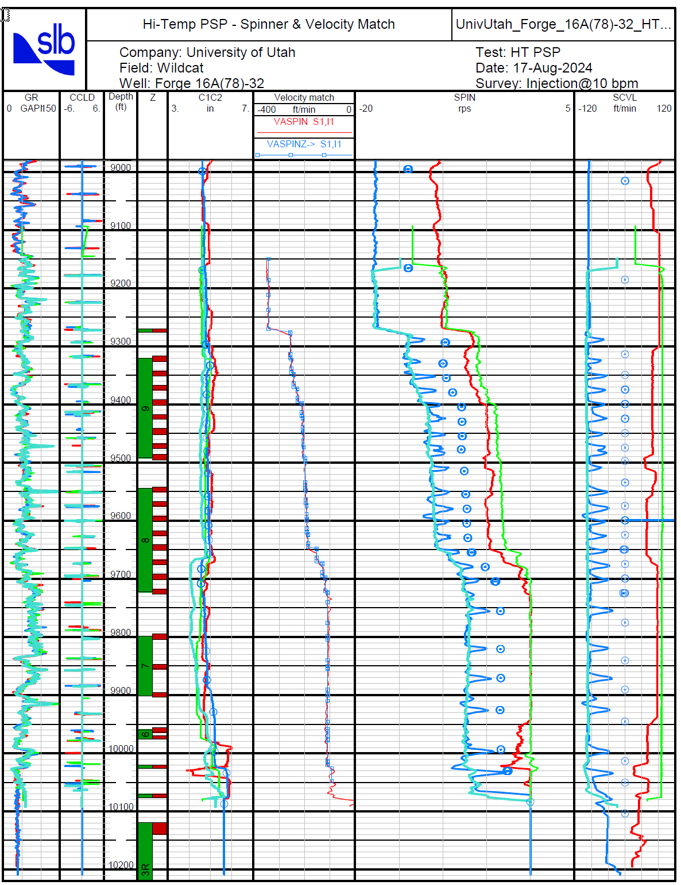

Figure 11. Injection profile in well 16A(78)-32.
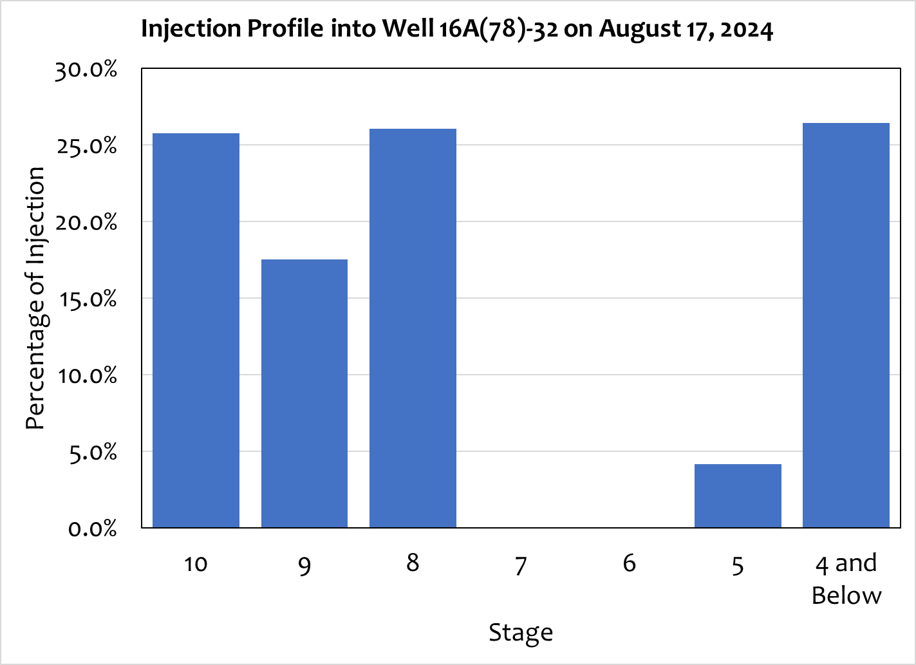
Figure 12. Notice no flow into the two unpropped stages (Stages 6 and 7), the strong contribution from the most “heelward” stages (all probably sharing the same entry in Well 16B(78)-32.

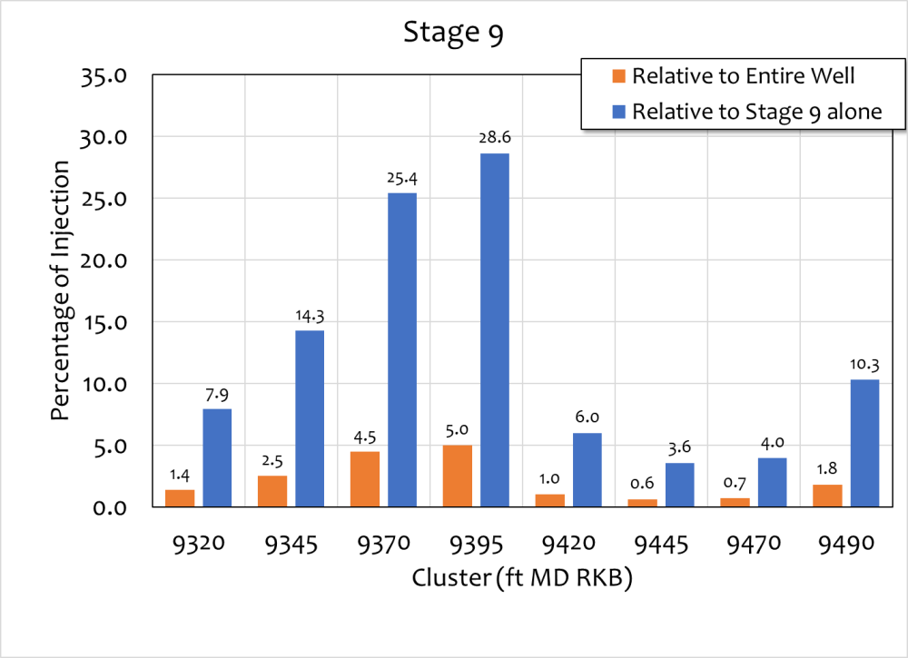
Figure 13. Flow partitioning in the eight clusters in Stage 9 showing “heelward” is favored (refer to Stage 8 in Figure 14, showing favoring “toeward” clusters).

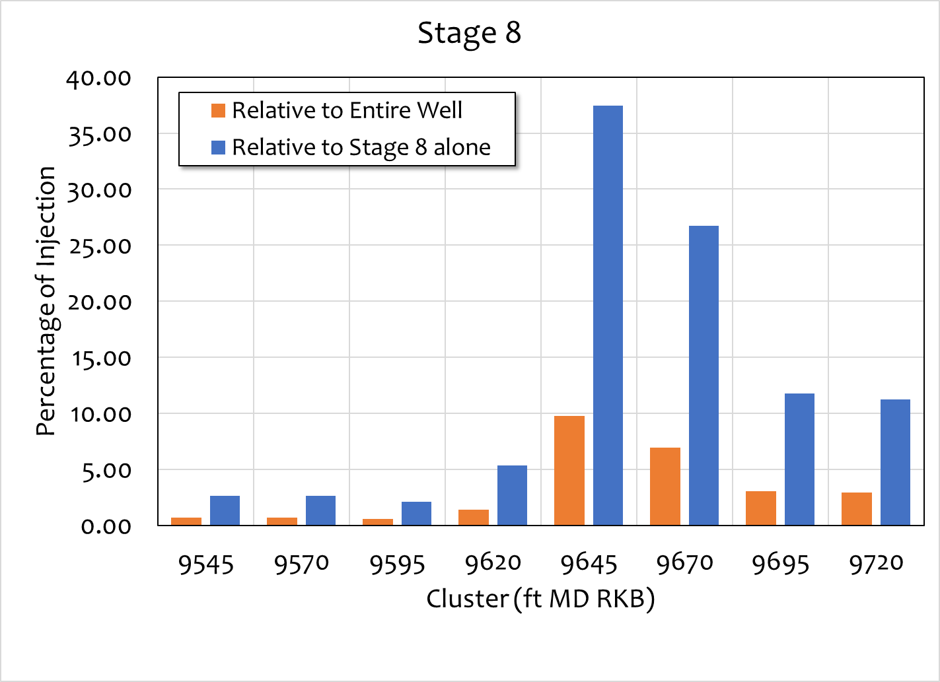
Figure 14. Flow partitioning in the eight clusters in Stage 8 showing “toeward” is favored (refer to Stage 9 in Figure 13, showing favoring “heelward” clusters).

The PLT/PTS survey run in well 16B(78)-32 is shown in Table 8 and Figures 15 through 22. The survey was carried out so that discrete clusters could be surveyed (see Table 9). The tool reached 9,240 ft MD RKB.

Table 8. Stage-Wise Partitioning of Flow for PLT/PTS in well 16B(78)-32
[Production is positive]

Stage | Perforations |  | Water | Water
Stage |  |  | (bpd) | (%)
5 | 9270 | 9276 | 3112.2 | 25.8%
4 | 9320 | 9493 | 4573.9 | 37.9%
3 | Below 9240 |  | 4388.3 | 36.3%
2 |  |  | 4388.3 | 36.3%
1 |  |  | 4388.3 | 36.3%
Totals |  |  | 12074.4 | 100.0%

Table 9. Cluster-Wise Partitioning of Flow for PLT/PTS in well 16B(78)-32
[Production is positive]

Stage | Perforations |  | Water | Water
Stage |  |  | (bpd) | (%)
5 | 8774 | 8778 | trace | trace
5 | 8834 | 8838 | 1309.0 | 10.8%
5 | 8870 | 8874 | 314.2 | 2.6%
5 | 8879 | 8883 | 1489.0 | 12.3%
4 | 8958 | 8962 | 1381.2 | 11.4%
4 | 8995 | 8999 | 765.9 | 6.3%
4 | 9026 | 9030 | 1439.9 | 11.9%
4 | 9054 | 9058 | 986.9 | 8.2%
3 | Below 9240 |  | 4388.3 | 36.3%
2 |  |  | 4388.3 | 36.3%
1 |  |  | 4388.3 | 36.3%
Totals |  |  | 12074.4 | 100.0%

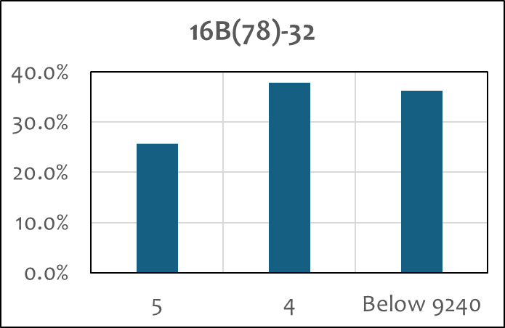

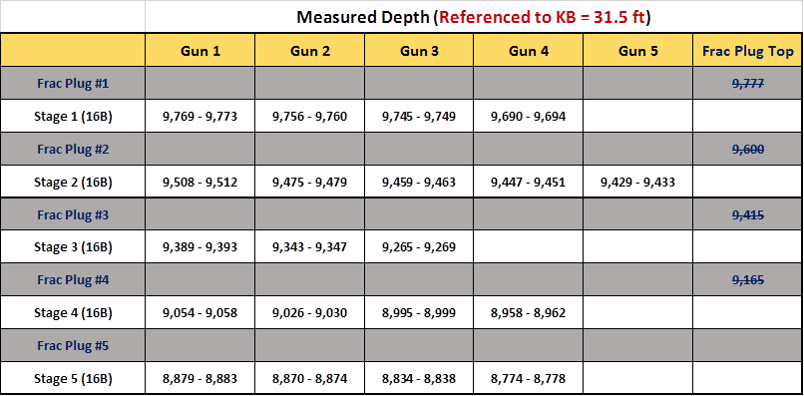

Figure 15. August 26, 2024, PLT/PTS on well 16B(78)-32, showing the distribution of inflow for stages 5 and 4 and cumulative below stage 4.

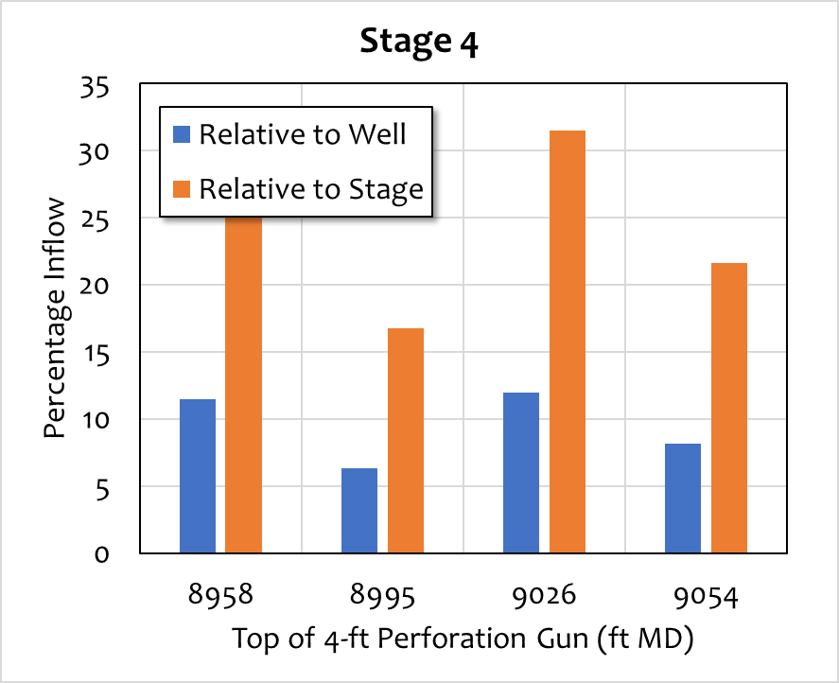
Figure 16. August 26, 2024, PLT/PTS on well 16B(78)-32, showing the distribution of inflow for stage 4.

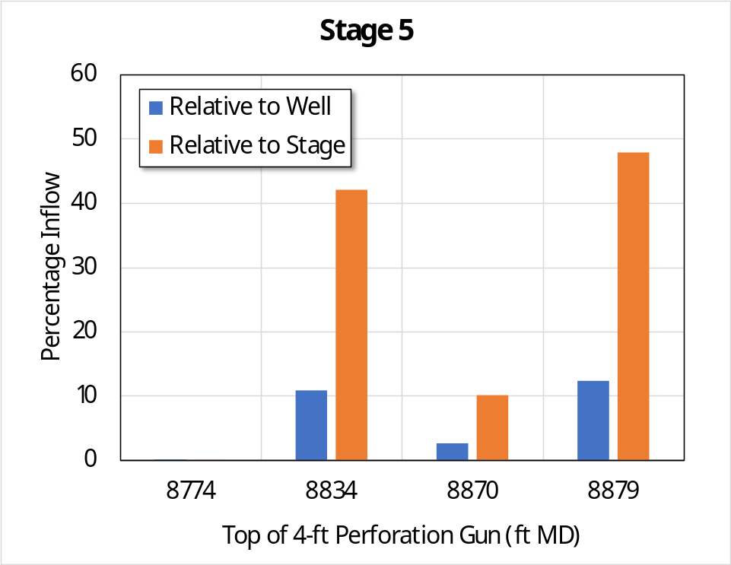
Figure 17. August 26, 2024, PLT/PTS on well 16B(78)-32, showing the distribution of inflow for stage 5. Note that stage 5 was perforated but not stimulated.

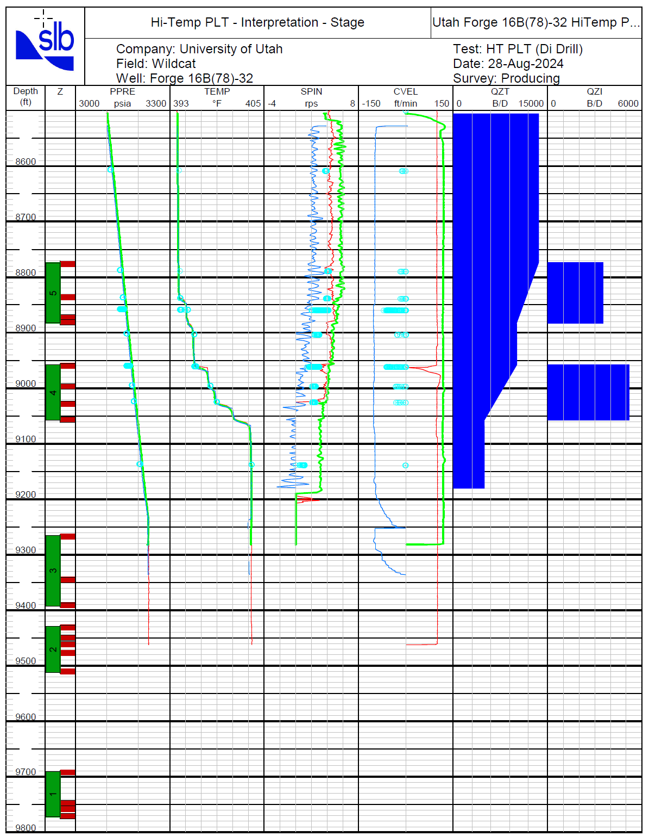

Figure 18. August 26, 2024, PLT/PTS on well 16B(78)-32, showing the distribution of inflow.
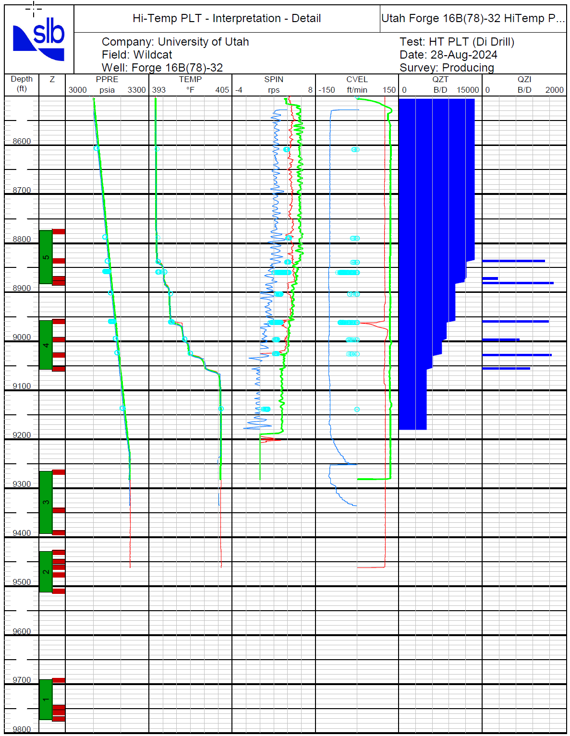

Figure 19. August 26, 2024, PLT/PTS on well 16B(78)-32, showing the distribution of inflow.

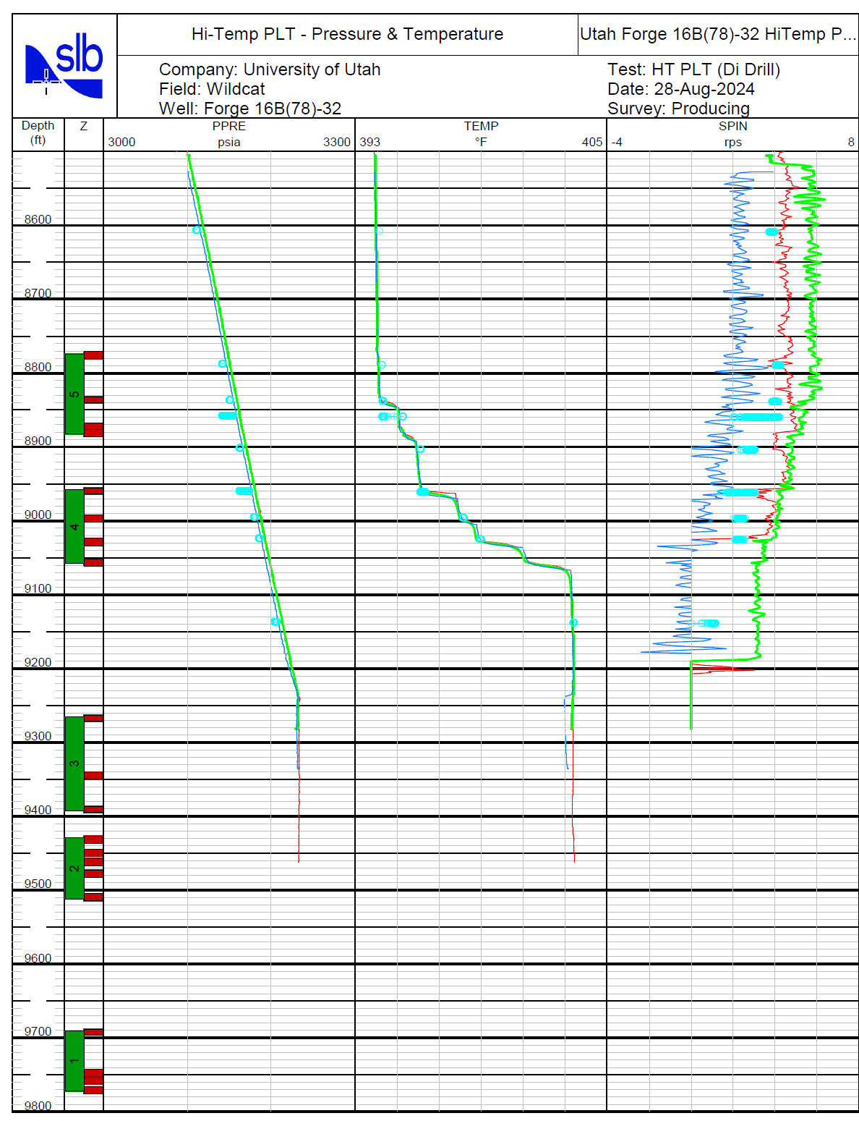

Figure 20. August 26, 2024, PLT/PTS on well 16B(78)-32, showing the distribution of inflow.

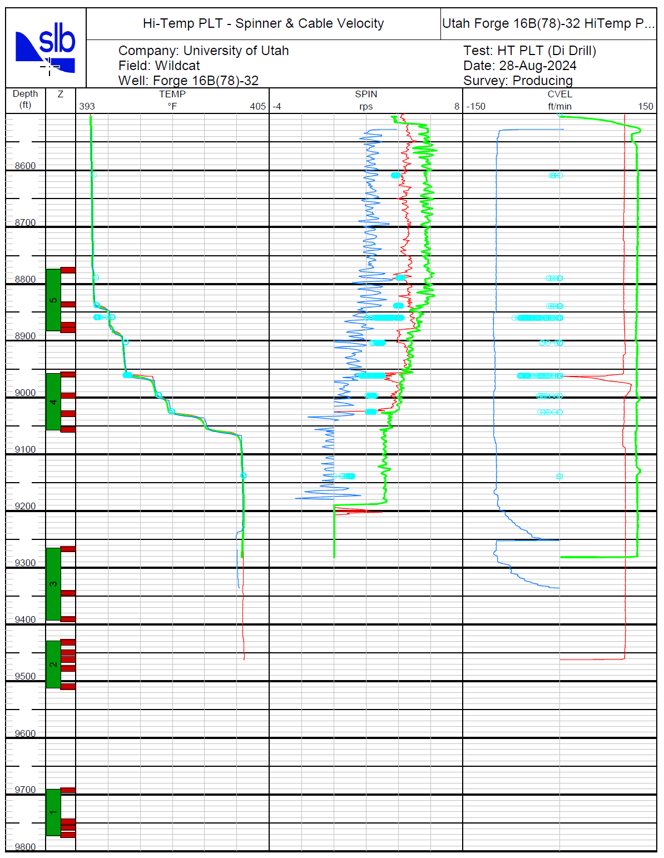

Figure 21. August 26, 2024, PLT/PTS on well 16B(78)-32, showing the distribution of inflow.

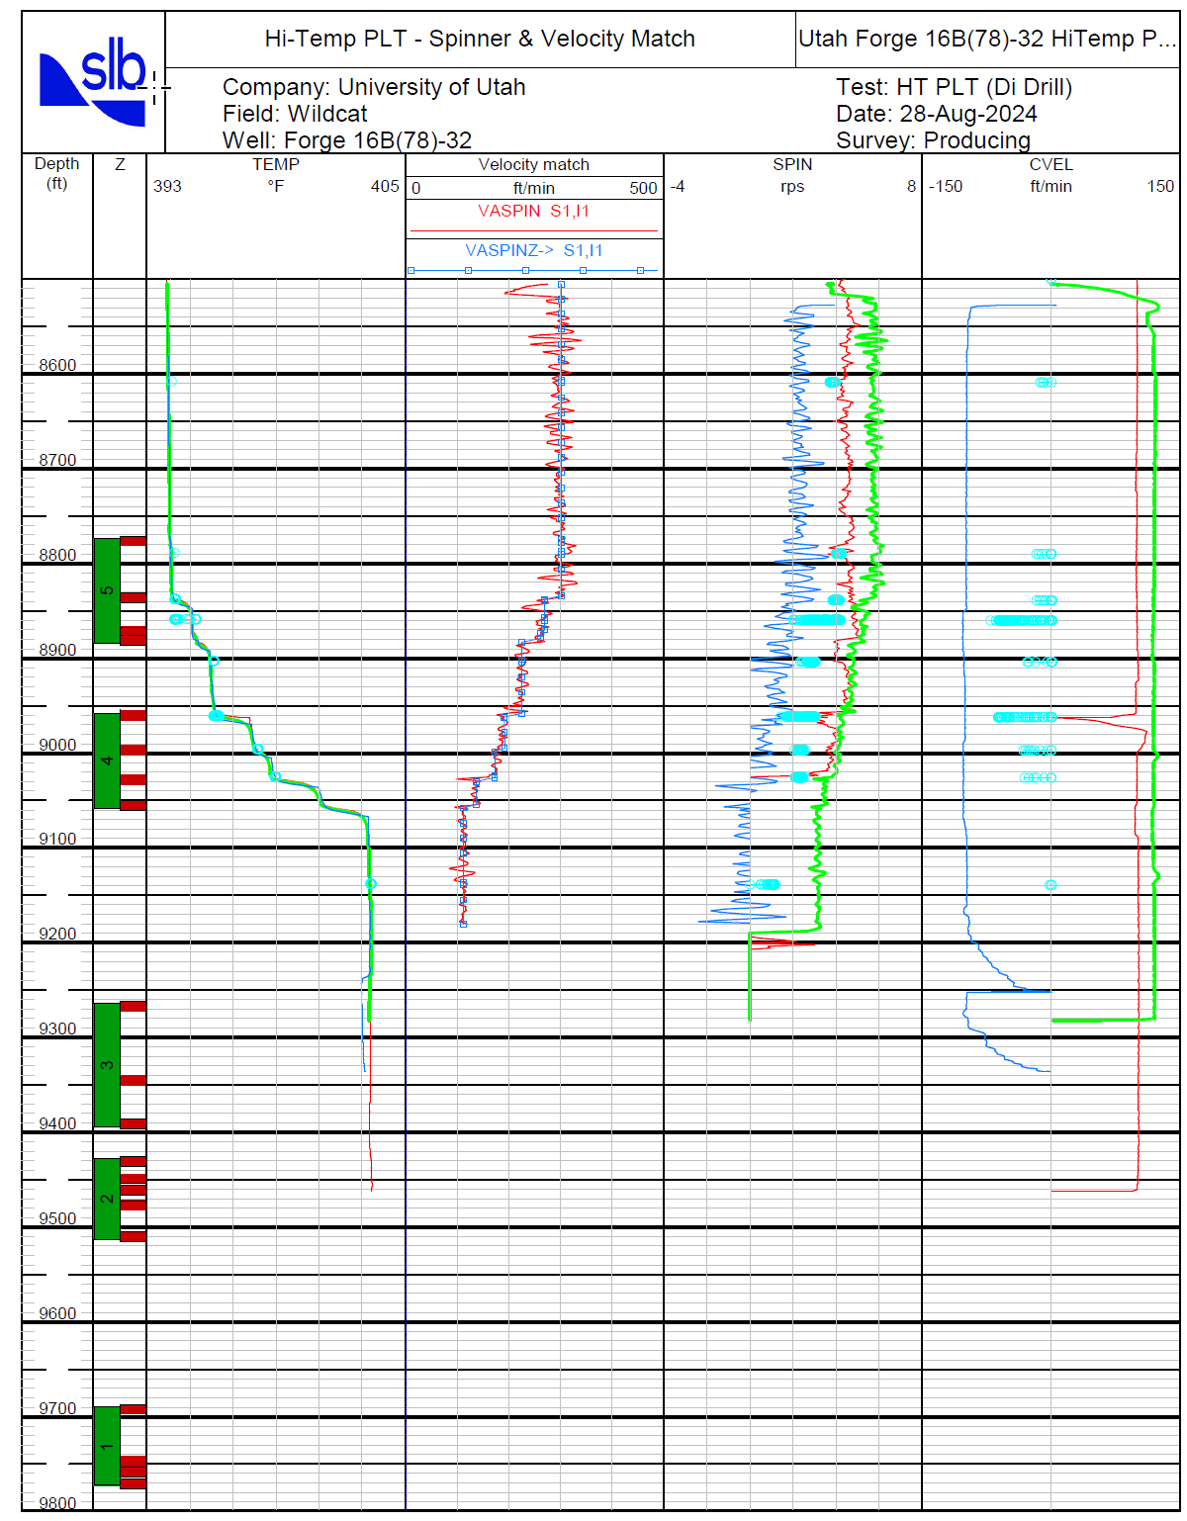

Figure 22. August 26, 2024, PLT/PTS on well 16B(78)-32, showing the distribution of inflow.

Sampling and Additive Metering/Testing Procedure

Pre-Test Assessments
One liter of water from the 125,000 bbl pit has been analyzed by Paul Heinstein, HWTR, LLC. The results are shown in Table 10.

Table 10. Water Analysis Per-Circulation (125,000 bbl pit)

Parameter | Units | Result
ATP free | RLU | 0
O₂ | ppm | 5 to 6
pH |  | 7.8
Conductivity | mS/cm | 10.95
SiO₂ | ppm | 102
Total Hardness | ppm as CaCO₃ | 560
Ca | ppm as CaCO₃ | 550
Mg | ppm as CaCO₃ | 10
M-alkalinity | ppm as CaCO₃ | 160
ORP | mV | 147
Fe | ppb as Fe | N/D
ABS | 520 nm | 0.153
SO₄ | ppm as SO₄ | 1500
Turbidity | NTU | 1.3

Data were also available from the nine-hour circulation test (Stuart Simmons, personal communication).

“Chemical analyses on produced fluids from well 16B were obtained in respect to a short term 9-hour circulation test between wells 16A(78)-32 and 16B(78)-32 on April 27, 2024. Injection into 16A commenced around 1 pm, and the first sample was collected 1.5 hours later. Subsequent samples were collected about every hour. Of these, four samples were submitted for … along with a sample from the Harpoon tank that coincides with perforation, injection, and stimulation at Stage 8 (Table 11).”

Table 11. Analytical results for injected and produced waters.
Concentrations in mg/kg (ppm).
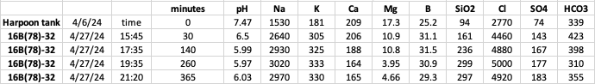

Simmons also observed (and provided Figure 23):

- “The rise in TDS as reflected by sharp increases in Cl, Na, and K parallels trends observed in flowback waters from 16A during the April 2022 stimulation. This means that in all likelihood, the waters sampled had traversed the reservoir from well 16A to 16B. The number of stimulated stages hosting active flow are unknown….
- “Changes from the composition of injected water are likely consequences of predominantly water-rock interaction. Based on the observation of halite (NaCl) in drill core from 16A at 5850 ft depth, the dissolution of soluble salts is implicated, accounting for the increases in in Cl, Na, and K. Sulfate (SO₄) also shows a sharp increase, suggesting dissolution of a sulfate mineral such as anhydrite (CaSO₄), which is widespread but occurs in trace amounts based on examination of drill cores and cuttings.
- “The Ca trend is interesting in so far as it decreases measurably from >200 to 165 mg/kg, in spite of evidence just noted for some sulfate mineral dissolution, which would release Ca into the aqueous phase. The net decrease in Ca is likely indication of some calcite deposition in the reservoir.
- “Mg decreases with time as was observed in the flowback waters in 16A from 2022. This could either be due to deposition of Mg-carbonate (i.e., dolomite) or incorporation into a clay mineral.
- “B increases parallel the sort of trends seen in the first two stimulated stages of 16A in 2022, so probably a result of water-rock interaction or dissolution of a soluble B-bearing mineral.
- “The 1.5 unit drop in pH is interesting, indicating incorporation of one or more weak acids (e.g., CO₂, B, or SiO₂). Geochemical modeling will conceivably provide clarity of which ones are most likely.
- “Unlike many of the other analytes, silica increases gradually plateauing in the last two samples close to 300 mg/kg, reflecting an equilibration temperature of 225°C. This matches the reservoir temperature but is much hotter than the temperature of the produced water.
- “In addition to being just at saturation with respect to quartz, the produced fluids at 225°C are supersaturated in anhydrite, dolomite and just barely undersaturated in calcite.
- “Roughly 100,000 barrels of fluid were injected during the April 2024 stimulation. Based on the increases in total dissolved salts (i.e., Na, K, Cl, SiO2, SO4) of 4150 mg/kg, the total dissolved mass related to this injection might have exceeded 65 tonnes.”

Based on those assessments, additive decisions were made:
- Biocide was not run but could be run if it were needed.
- Upstream and downstream monitoring would be carried out.
- A dual function calcite/sulfate inhibitor would be metered in and adjusted as required based on monitoring results.
- An imidazole based corrosion inhibitor was also metered in.

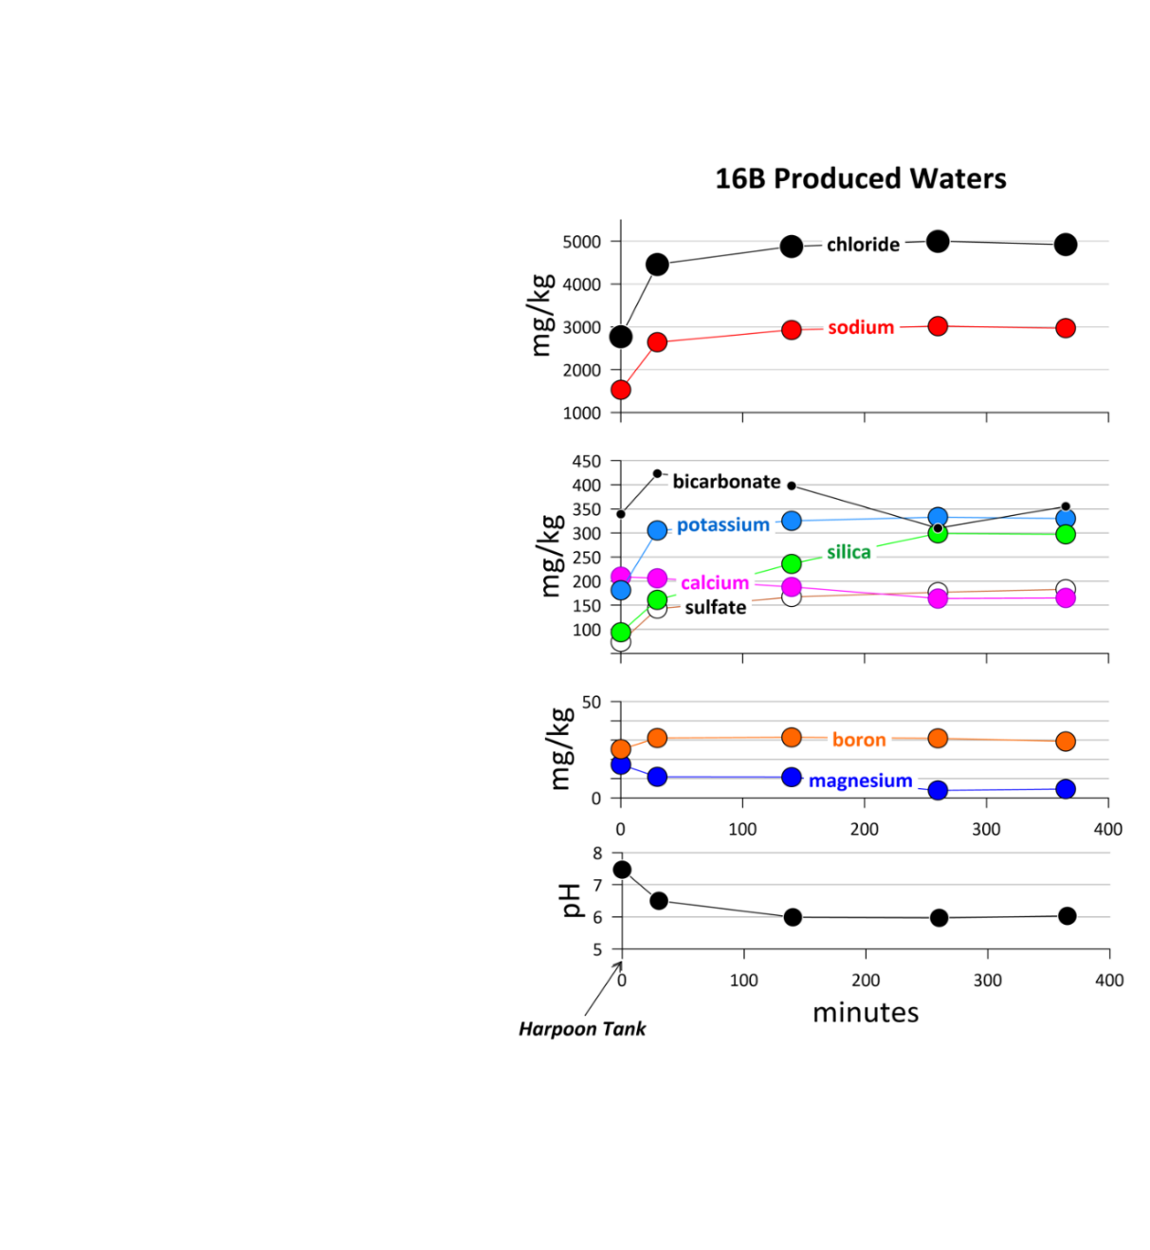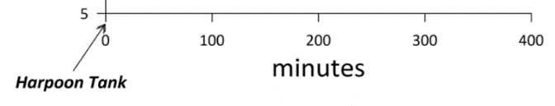 | 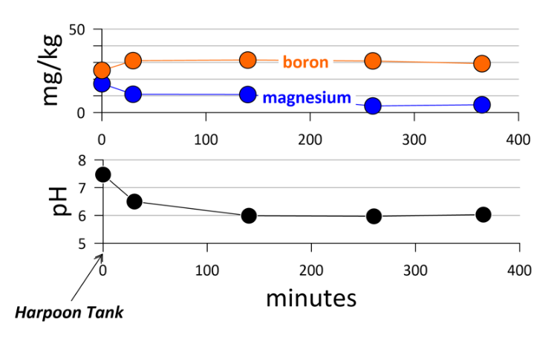

Figure 23. Time series plots of analytical results for injected and produced waters from well 16B(78)-32.

Assessments During Pumping

Appendix B shows water analyses just before the pumps and before the produced fluid was circulated into the sump. The measured values appear to be higher than those determined by an analytical laboratory, but there is qualitative agreement.

Injection Records

Figure 24 shows the injection chronology. The fluctuations in flow rate at the very end of the test are the injection cycling pumped for the CSULB research project. Subsequent figures progressively show temperatures and rates and ultimately an efficiency (mass flow rate out/mass flow rate in) approaching 90%.

Subsequent data have been adjusted based on supplementary calibration.
- The measurement of temperature downstream of the 16B(78)-32 wellhead and upstream of the atmospheric separator was adjusted. The thermocouple in the tee did not extend fully into the flow stream and read less than the temperature gun. An adjustment for the difference was applied to the raw data (refer to Figure 25).
- The companion pressure transducer to the thermocouple described in item 1 characteristically read erratically. A manual gauge was installed and those periodic readings were used in steam quality and similar calculations, where appropriate (refer to Figure 25). This device read high, at least some of the time because of impairment of the flow meter.
- Flow meters were calibrated directly in line with the Liberty Oilfield Services pumping equipment. Results are seen in Figure 26. These were used to correct the readings of the flow meters exiting the separator.

Figure 27 shows the wellhead pressure at well 16B(78)-32. That pressure probably is slightly high because of the malfunctioning flowmeter. The manual gauge downstream of this (but upstream of the separator) was used for steam quality calculations. Two temperatures upstream of the separator are shown. One is the raw Pason temperature and the second is an estimate of the real temperature as determined from a temperature gun (see item 1 immediately above).

Figure 28 shows the flowmeter data downstream of the 16B(78)-32 wellhead. All flowmeter data have been corrected based on the field calibration (see item 3 immediately above).

Figure 29 shows mass flow rates calculated for the injector and calculated at the producer using corrected data downstream of the separator and the calculated steam fraction.

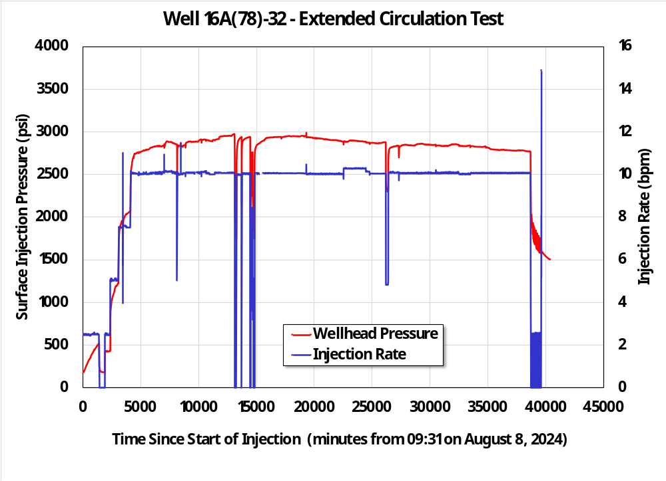
Figure 24. Injection pressure and rate during the circulation testing.

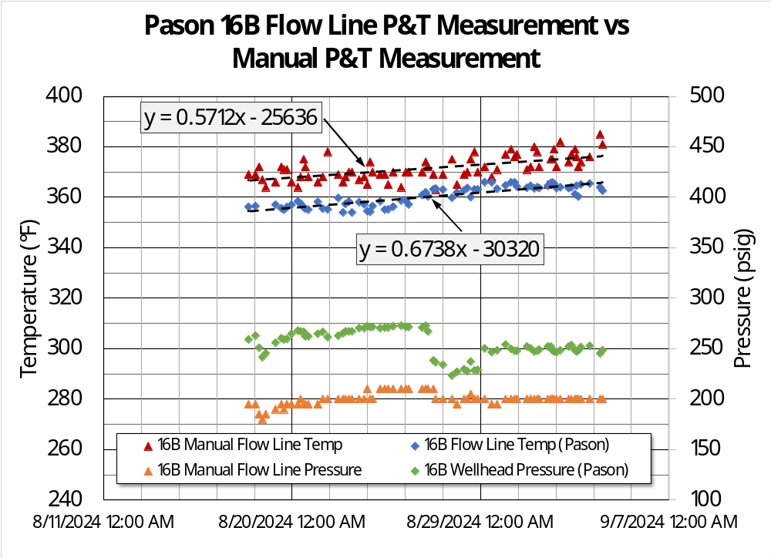
Figure 25. Difference between in-line and infrared temperature readings and pressure transducer and manual pressure gauge.
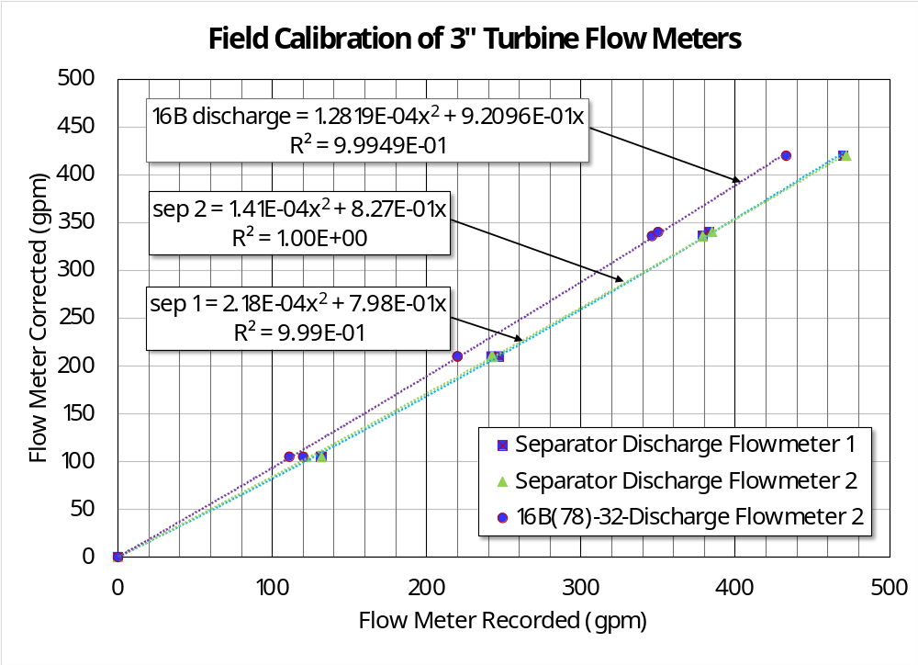
Figure 26. Regressed equations for correcting raw Pason flow meter data to data consistent with Liberty Oilfield Services measurement equipment.
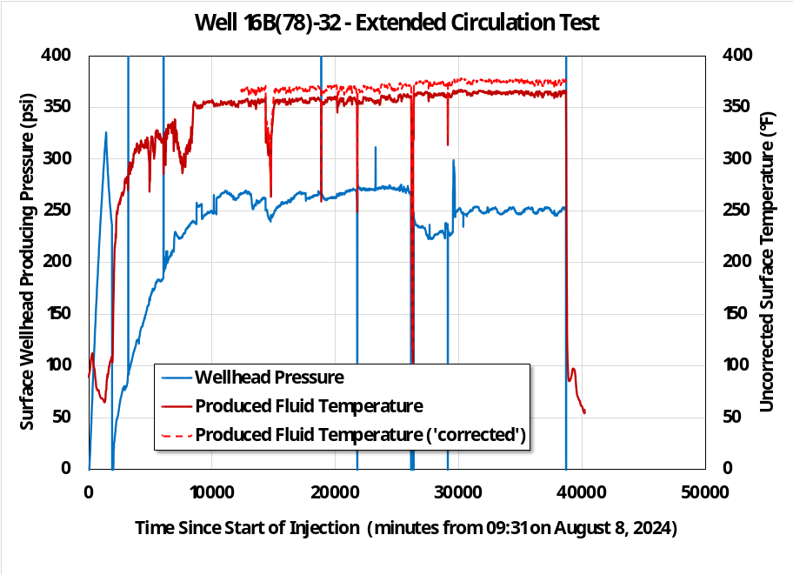
Figure 27. These data are the wellhead pressure and the in-line temperature before the separator. This temperature is an underestimate because the thermocouple placement did not reach the fluid flowing in the flow line from well 16B(78)-32 to the separator. Temperature gun measurements of the flow line are about 8-10°F higher on average.

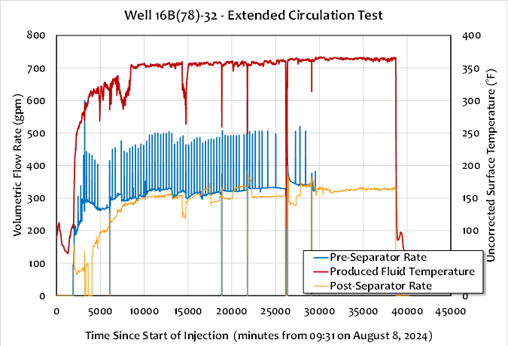
Figure 28. This shows the suspect flow meter upstream of the separator, the sum of the two flow meters downstream of the separator, and the uncorrected temperature measured just upstream of the separator. All raw flow meter data have been corrected based on a post-test calibration directly using the frac pumps that were injecting into well 16A(78)-32.
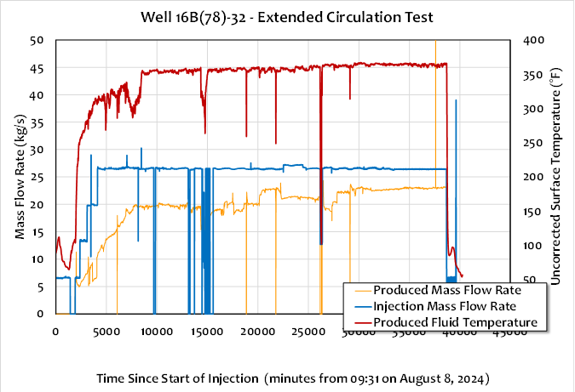
Figure 29. Mass flow rates were measured using a boiling point of 202.2°F at an elevation of 5415 ft MSL and the associated density for the fluid leaving the separator. A 19.6% steam fraction was calculated and used in these same calculations and added to the separator discharge to get the produced mass flow rate. Measured temperature, where available (measured until just the last part of the circulation) was used to calculate the injection mass flow rate.

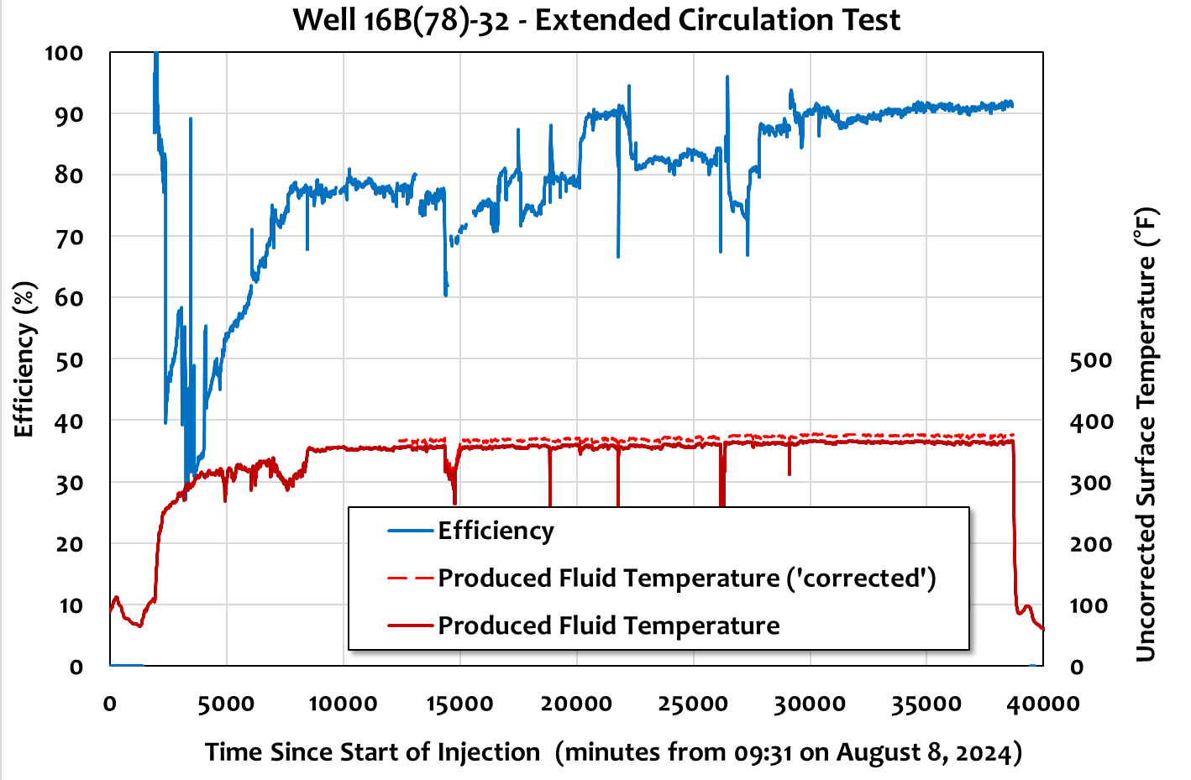
Figure 28. The ratio of mass flow rates was used to calculate efficiency – approximately 90%.

Appendix A: Nine-hour Circulation Test (April 27, 2024)
The culmination of the fracturing experiment was a nine-hour circulation test, pumping down casing in Well 16A(78)-32 and recovering produced fluid from well 16B(78)-32. Figure A-1 documents the events.

As can be seen in Figure A-1, the rate was gradually increased. With continued injection the pressure built. Much of the fluid that had been injected during stimulation had been flowed back while drilling out frac plugs (matrix permeability is low) and the previously created fracture system was partially refilled.

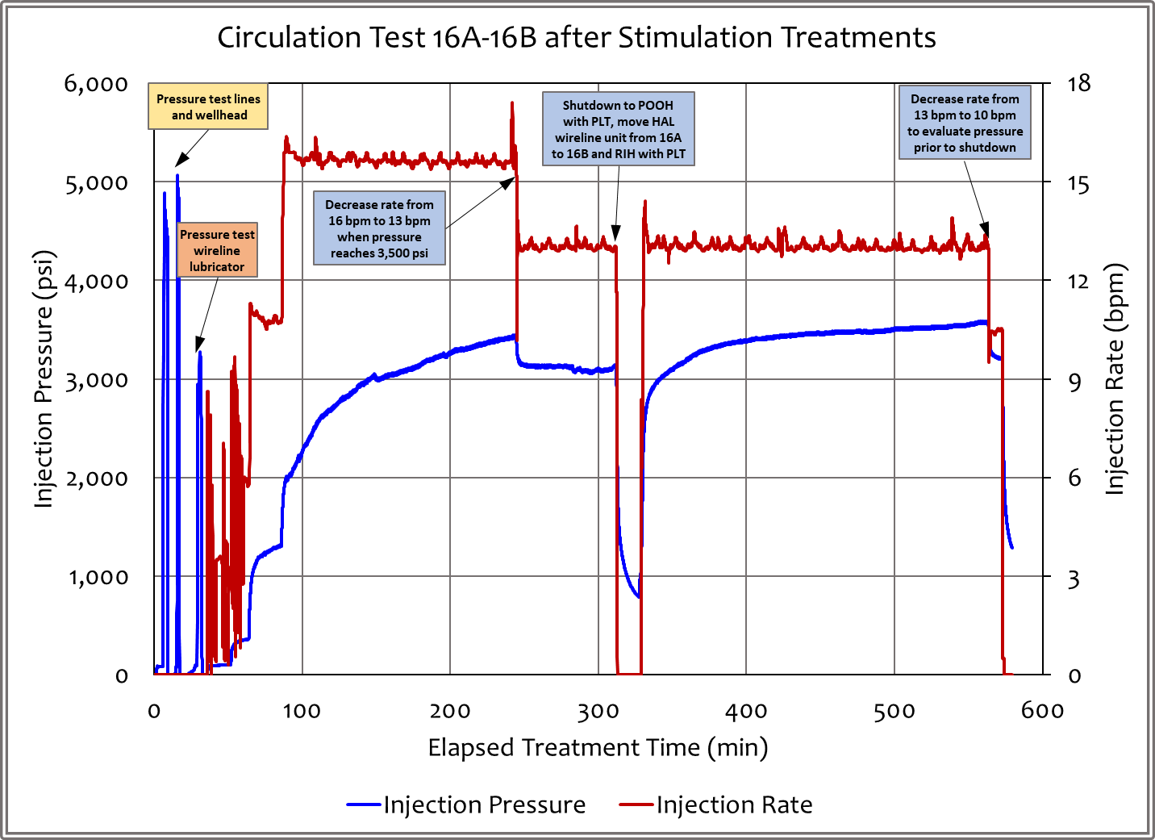
Figure A-1. Surface injection pressure and rate while pumping into well 16A(78)-32.

After pumping at about 16 bpm for some time, the pressure at the surface increased to where supplementary fracture propagation would be expected and there were some indications of this with the injection pressure. The rate was dropped. While this was ongoing a PLT/PTS (production logging tool/pressure-temperature-spinner) profiled well 16A(78)-32. The shutdown after about 310 minutes of pumping was so that this tool could be moved to the production well (16B(78)-32). After lubricating the PLT into the production well, a rate of about 13.5 bpm was re-established and maintained until shutdown just short of nine hours of operation.

The rate and temperature data are shown in Figure A-2. The rate of outflow from the production well gradually and fairly monotonically built to 8.2 bpm. This is close to a 70% recovery efficiency and it is hypothesized that this efficiency will increase with time as the created fracture system is filled and stiffened and connections improve. The temperature tracked the flow and reached 282°F before the termination of the test.
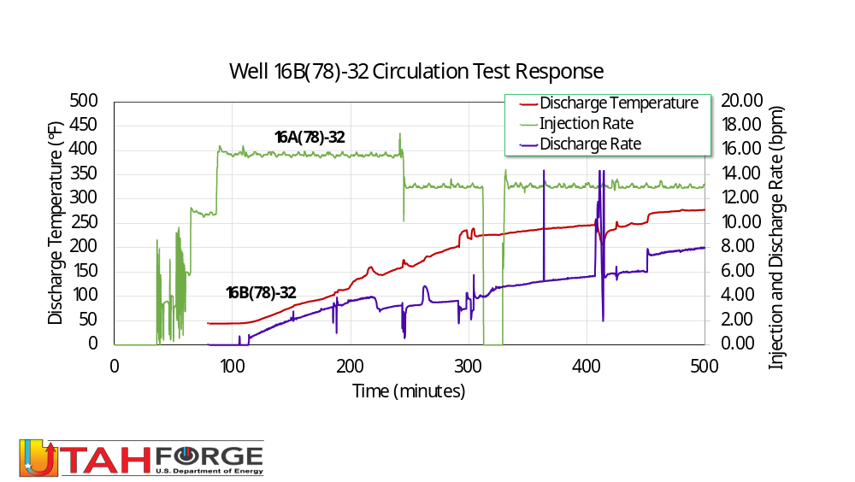

Figure A-2. The rate of injection is shown in green (secondary y-axis). The rate of outflow from the production well gradually and fairly monotonically built to 8.2 bpm (purple curve and secondary y-axis). This is close to a 70% recovery efficiency and it is hypothesized that this efficiency will increase with time as the created fracture system is completely filled and stiffened and connections improve. The temperature (red curve and primary y-axis) tracked the flow and reached 282°F before the termination of the test.

The flow partitioning data for well 16B(78)-32 are shown in Figure A-3. A high-level summary is that there appeared to be flow into the entire well. Stages 1 to 6 could not be mapped discretely and the individual clusters in Stage 8 were not resolved individually. However, the assessment of the distribution of flow in the eight clusters of Stage 9 is quite clear. Individual operators will need to decide if this degree of perforation efficiency meets their criteria or if they need to consider alternative completion strategies. For completeness, Figure A-4 is the flow partitioning for the PLT in well 16B(78)-32. The tool could not get down deep enough to discriminate the distribution of flow in the different zones.
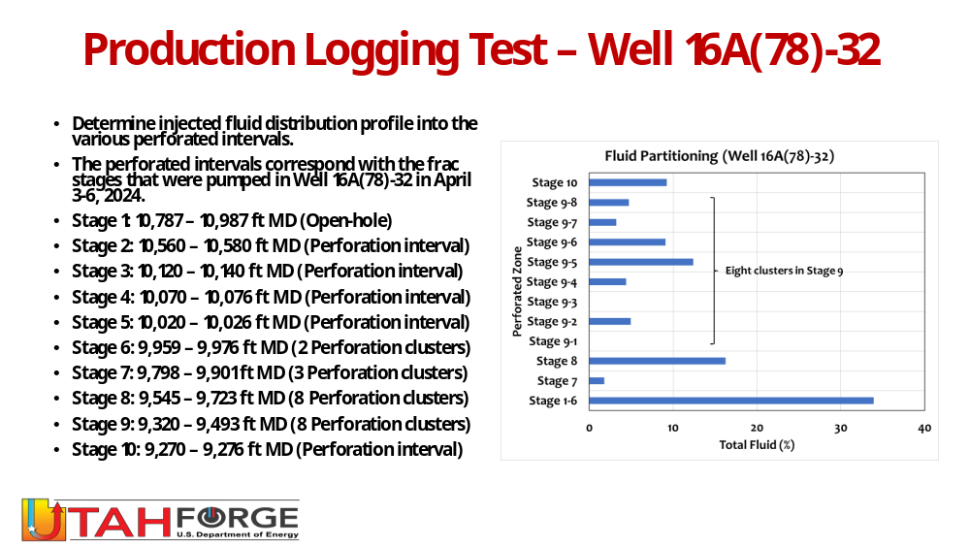
Figure A-3. Flow partitioning while injecting into well 16A(78)-32.
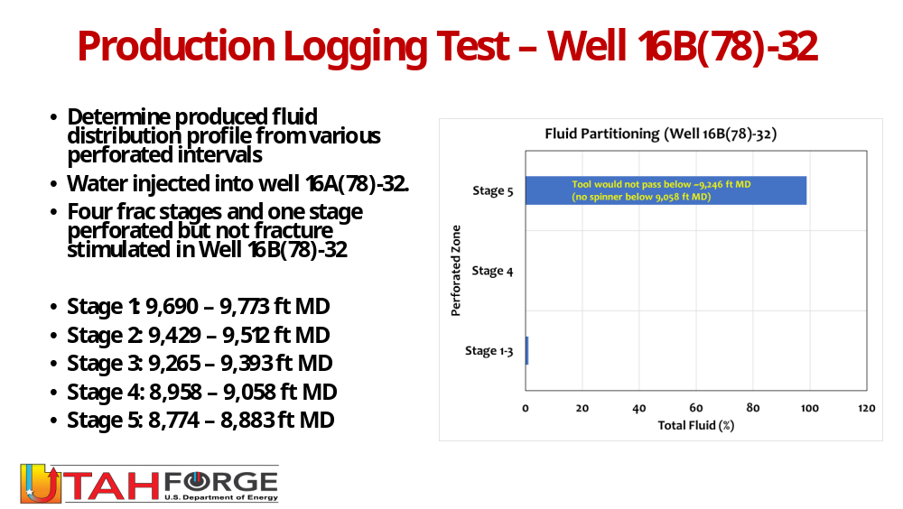
Figure A-4. Flow partitioning while injecting into well 16B(78)-32. Not reliable because the tool could not enter below the top section.

Appendix B: On-Location Water Analyses

Table B-1. Summary of Chemical Usage and Injected Volumes

 |  | Daily | Daily CI | Daily SI | Cum | Cum CI | Cum SI | Daily
 |  | Volume | HWTR 6000 | SI-5045RM | Volume | HWTR 6000 | SI-5045RM | Avg Pump
 | Day & Date | Treated | Used | Used | Treated | Used | Used | Rate
 |  | (bbl) | (gal) | (gal) | (bbl) | (bbl) | (gal) | (bpm)
1 | Thursday, August 8, 2024 | 2,397 | 0.75 | 5.18 | 2,397 | 0.75 | 5.18 | 2.5
2 | Friday, August 9, 2024 | 2,346 | 0.74 | 5.07 | 4,743 | 1.49 | 10.25 | 2.5
3 | Saturday, August 10, 2024 | 8,979 | 2.82 | 19.40 | 13,722 | 4.30 | 29.65 | 6.25
4 | Sunday, August 11, 2024 | 13,633 | 4.27 | 29.46 | 27,355 | 8.58 | 59.11 | 9.5
5 | Monday, August 12, 2024 | 14,414 | 4.52 | 31.14 | 41,769 | 13.10 | 90.25 | 10
6 | Tuesday, August 13, 2024 | 14,481 | 4.54 | 31.29 | 56,250 | 17.64 | 121.54 | 10
7 | Wednesday, August 14, 2024 | 14,373 | 4.51 | 31.06 | 70,623 | 22.14 | 152.59 | 10
8 | Thursday, August 15, 2024 | 13,674 | 4.29 | 29.55 | 84,297 | 26.43 | 182.14 | 10
9 | Friday, August 16, 2024 | 14,408 | 4.52 | 31.13 | 98,705 | 30.95 | 213.27 | 10
10 | Saturday, August 17, 2024 | 12,808 | 4.02 | 27.67 | 111,513 | 34.96 | 240.95 | 8.9
11 | Sunday, August 18, 2024 | 12,368 | 3.88 | 26.72 | 123,881 | 38.84 | 267.67 | 8.6
12 | Monday, August 19, 2024 | 14,417 | 4.52 | 31.15 | 138,298 | 43.36 | 298.82 | 10
13 | Tuesday, August 20, 2024 | 14,432 | 4.52 | 31.18 | 152,730 | 47.89 | 330.00 | 10
14 | Wednesday, August 21, 2024 | 14,415 | 4.52 | 31.15 | 167,145 | 52.40 | 361.15 | 10
15 | Thursday, August 22, 2024 | 14,356 | 4.50 | 31.02 | 181,501 | 56.91 | 392.17 | 10
16 | Friday, August 23, 2024 | 14,356 | 4.50 | 31.02 | 195,857 | 61.41 | 423.19 | 10
17 | Saturday, August 24, 2024 | 14,733 | 4.62 | 31.83 | 210,590 | 66.03 | 455.02 | 10.23
18 | Sunday, August 25, 2024 | 14,546 | 4.56 | 31.43 | 225,136 | 70.59 | 486.45 | 10.1
19 | Monday, August 26, 2024 | 13,294 | 4.17 | 28.72 | 238,430 | 74.75 | 515.17 | 9.23
20 | Tuesday, August 27, 2024 | 13,779 | 4.32 | 29.77 | 252,209 | 79.08 | 544.95 | 10
21 | Wednesday, August 28, 2024 | 14,407 | 4.52 | 31.13 | 266,616 | 83.59 | 576.07 | 10
22 | Thursday, August 29, 2024 | 14,398 | 4.51 | 31.11 | 281,014 | 88.11 | 607.18 | 10
23 | Friday, August 30, 2024 | 14,396 | 4.51 | 31.11 | 295,410 | 92.62 | 638.29 | 10
24 | Saturday, August 31, 2024 | 14,369 | 4.51 | 31.05 | 309,779 | 97.13 | 669.34 | 10
25 | Sunday, September 1, 2024 | 14,405 | 4.52 | 31.12 | 324,184 | 101.64 | 700.46 | 10
26 | Monday, September 2, 2024 | 14,405 | 4.52 | 31.12 | 338,589 | 106.16 | 731.59 | 10
27 | Tuesday, September 3, 2024 | 14,407 | 4.52 | 31.13 | 352,996 | 110.67 | 762.71 | 10
28 | Wednesday, September 4, 2024 | 4,312 | 1.35 | 9.32 | 357,308 | 112.03 | 772.03 | 9.55

Table B-2. Summary of Water Quality Leaving the Minion Tank (upstream of pumps)

 |  | Outlet of the MINION Tank
 |  |  |  |  |  | Total |  |  |  | Dissolved
 | Day & Date | pH | ORP | Temp | Calcium | Alkalinity | Conductivity | Iron | Turbidity | Oxygen
 |  |  | (mV) | (°F) | (ppm) | (ppm) |  | (ppm) |  | (ppm)
1 | Thursday, August 8, 2024
2 | Friday, August 9, 2024 | 7.80 | 179 | 77.02 | 951 | 228 | 11 | 0 | 2 | 5
3 | Saturday, August 10, 2024 | 7.55 | 73 | 75.65 | 593 | 200 | 11 | 0 | 3 | 5
4 | Sunday, August 11, 2024 | 7.31 | 107 | 75.65 | 580 | 180 | 11 | 0 | 3 | 5
5 | Monday, August 12, 2024 | 7.36 | 106 | 75.56 | 608 | 180 | 10 | 0 | 6 | 6
6 | Tuesday, August 13, 2024 | 7.51 | 98 | 75.98 | 570 | 180 | 10 | 0 | 5 | 6
7 | Wednesday, August 14, 2024 | 7.51 | 98 | 75.98 | 570 | 180 | 10 | 0 | 5 | 6
8 | Thursday, August 15, 2024 | 7.72 | 78 | 74.73 | 624 | 180 | 11 | 0 | 7 | 5
9 | Friday, August 16, 2024 | 7.76 | 84 | 75.35 | 560 | 180 | 11 | 0 | 14 | 5
10 | Saturday, August 17, 2024 | 7.63 | 78 | 72.00 | 558 | 180 | 12 | 0 | 18 | 6
11 | Sunday, August 18, 2024 | 7.46 | 87 | 73.75 | 517 | 180 | 12 | 0 | 15 | 5
12 | Monday, August 19, 2024 | 7.09 | 84 | 77.92 | 509 | 180 | 12 | 0 | 22 | 6
13 | Tuesday, August 20, 2024 | 7.07 | 92 | 79.79 | 565 | 180 | 12 | 0 | 20 | 5
14 | Wednesday, August 21, 2024 | 7.15 | 108 | 80.77 | 490 | 180 | 12 | 0 | 24 | 3
15 | Thursday, August 22, 2024 | 7.11 | 177 | 79.27 | 493 | 180 | 12 | 0 | 26 | 2
16 | Friday, August 23, 2024 | 7.48 | 136 | 77.65 | 505 | 180 | 12 | 0 | 34 | 1
17 | Saturday, August 24, 2024 | 7.58 | 140 | 77.05 | 570 | 180 | 12 | 0 | 32 | 1
18 | Sunday, August 25, 2024 | 7.30 | 110 | 76.95 | 495 | 180 | 12 | 0 | 30 | 1
19 | Monday, August 26, 2024 | 7.10 | 123 | 75.34 | 505 | 180 | 13 | 0 | 24 | 1
20 | Tuesday, August 27, 2024 | 7.06 | 120 | 75.56 | 500 | 180 | 13 | 0 | 28 | 1
21 | Wednesday, August 28, 2024 | 7.56 | 118 | 75.02 | 520 | 180 | 71 | 0 | 23 | 1
22 | Thursday, August 29, 2024 | 6.96 | 82 | 76.10 | 520 | 180 | 13 | 0 | 23 | 1
23 | Friday, August 30, 2024 | 6.90 | 117 | 77.45 | 505 | 180 | 13 | 0 | 24 | 1
24 | Saturday, August 31, 2024 | 7.20 | 80 | 78.00 | 485 | 180 | 13 | 0 | 25 | 1
25 | Sunday, September 1, 2024 | 7.44 | 80 | 81.55 | 505 | 180 | 14 | 0 | 26 | 1
26 | Monday, September 2, 2024 | 7.04 | 50 | 81.12 | 460 | 180 | 13 | 0 | 28 | 1
27 | Tuesday, September 3, 2024 | 6.87 | 49 | 81.40 | 492 | 180 | 13 | 0 | 22 | 1
28 | Wednesday, September 4, 2024 | 6.80 | 64 | 79.80 | 535 | 180 | 14 | 0 | 24 | 1

Table B-3. Summary of Water Quality Entering Sump (downstream of separator)

 |  | Outlet of the Geothermal Separator
 |  |  |  |  |  | Total |  |  |  | Dissolved
 | Day & Date | pH | ORP | Temp | Calcium | Alkalinity | Conductivity | Iron | Turbidity | Oxygen
 |  |  | (mV) | (°F) | (ppm) | (ppm) |  | (ppm) |  | (ppm)
1 | Thursday, August 8, 2024
2 | Friday, August 9, 2024 | 7.07 | 2 | 104.63 | 581 | 240 | 20 | 6 | 66 | 3
3 | Saturday, August 10, 2024 | 7.60 | -27 | 122.08 | 487 | 240 | 20 | 16 | 61 | 2
4 | Sunday, August 11, 2024 | 7.91 | -25 | 128.96 | 438 | 240 | 18 | 1 | 68 | 2
5 | Monday, August 12, 2024 | 7.92 | -10 | 138.08 | 367 | 240 | 17 | 0 | 47 | 1
6 | Tuesday, August 13, 2024 | 7.90 | -6 | 140.95 | 377 | 240 | 17 | 0 | 49 | 1
7 | Wednesday, August 14, 2024 | 7.90 | -6 | 140.95 | 377 | 240 | 17 | 0 | 49 | 1
8 | Thursday, August 15, 2024 | 7.77 | 0 | 138.81 | 348 | 240 | 16 | 0 | 33 | 1
9 | Friday, August 16, 2024 | 7.83 | 8 | 136.08 | 330 | 240 | 16 | 0 | 30 | 1
10 | Saturday, August 17, 2024 | 7.83 | 15 | 138.61 | 346 | 240 | 16 | 0 | 27 | 1
11 | Sunday, August 18, 2024 | 7.59 | 21 | 145.27 | 377 | 240 | 17 | 0 | 28 | 1
12 | Monday, August 19, 2024 | 7.38 | 23 | 145.46 | 386 | 240 | 17 | 0 | 25 | 1
13 | Tuesday, August 20, 2024 | 7.70 | 8 | 158.20 | 461 | 240 | 17 | 0 | 26 | 1
14 | Wednesday, August 21, 2024 | 7.65 | 46 | 141.17 | 465 | 210 | 17 | 0 | 22 | 1
15 | Thursday, August 22, 2024 | 7.79 | 17 | 140.24 | 367 | 233 | 17 | 0 | 22 | 1
16 | Friday, August 23, 2024 | 7.72 | 40 | 143.65 | 375 | 240 | 17 | 0 | 24 | 1
17 | Saturday, August 24, 2024 | 7.68 | 36 | 149.95 | 365 | 240 | 17 | 0 | 23 | 1
18 | Sunday, August 25, 2024 | 7.78 | 24 | 152.60 | 375 | 240 | 17 | 0 | 28 | 1
19 | Monday, August 26, 2024 | 7.79 | 17 | 143.62 | 335 | 240 | 17 | 0 | 50 | 1
20 | Tuesday, August 27, 2024 | 7.71 | 14 | 156.25 | 305 | 240 | 17 | 0 | 32 | 1
21 | Wednesday, August 28, 2024 | 7.60 | 24 | 154.40 | 325 | 240 | 17 | 0 | 26 | 1
22 | Thursday, August 29, 2024 | 7.76 | 24 | 154.15 | 300 | 240 | 17 | 0 | 38 | 2
23 | Friday, August 30, 2024 | 7.72 | 36 | 104.05 | 320 | 240 | 17 | 0 | 42 | 1
24 | Saturday, August 31, 2024 | 6.14 | 130 | 157.10 | 395 | 240 | 17 | 0 | 28 | 1
25 | Sunday, September 1, 2024 | 6.18 | 34 | 155.45 | 355 | 240 | 17 | 0 | 16 | 1
26 | Monday, September 2, 2024 | 7.82 | 53 | 150.35 | 390 | 240 | 17 | 0 | 23 | 1
27 | Tuesday, September 3, 2024 | 6.51 | 116 | 145.75 | 345 | 240 | 18 | 0 | 18 | 1
28 | Wednesday, September 4, 2024 | 7.61 | 30 | 153.20 | 368 | 240 | 17 | 1 | 37 | 1

Table B-4

